

KAUNAS UNIVERSITY OF TECHNOLOGY

FACULTY OF INFORMATICS

T120B166 Development of Computer Games and Interactive Applications

*In search of Light*

|  |
| --- |
| *IFF-6/8, Tadas Laurinaitis* |
|  |
| Date: 2019*.03.12* |

Kaunas, 2019

Tables of Contents

Tables of Images 3

Description of Your Game 4

Laboratory work #1 5

List of tasks 5

Solution 5

Task #1. *Add atleast 10 x 10 scenario elements* 5

Task #2. *Add 50 models to map* 5

Task #3. *Add 10 light sources to map* 6

Task #4. *Add atleast 10 sounds and 5 background music* 12

Task #5. *Add atleast 20 different materials* 12

Literature list 13

ANNEX 14

# **Tables of Images**

Figure 1 Screenshot #1 5

Figure 2. Screenshot #1 5

Figure 3. Light #1 6

Figure 4 Light #2 7

Figure 5 Light #3 7

Figure 6 Light #4 8

Figure 7 Light #5 8

Figure 8 Light #6 9

Figure 9 Light #7 9

Figure 10 Light #8 10

Figure 11 Light #9 11

Figure 12 Light #10 11

Figure 13. Screenshot #3 12

Figure 15 Screenshot #1 12

Figure 16 Materials #1 12

Figure 17 Materials #2 13

Figure 18 Materials #3 13

# **Description of Your Game**

Description of Your Game.

1. 3D or 2D? *3D.*
2. What type is your game? *A 3rd person adventure RPG.*
3. What genre is your game? *A 3rd person adventure RPG.*
4. Platforms (mobile, PC or both?) *PC.*
5. Scenario Description. *A spaceship crashes on a distant unknown planet on which the people are still living in the medieval times. The Survivor has to explore the planet, meet the locals, aid them in their quests and find a way to get back to his own home planet.*

**Laboratory work #1**

**List of tasks** (main functionality of your project)

1. Add 50 models to map #1
2. Add 10 Light sources to map #2
3. Add 10 sound and 5 background music effects #3
4. Create atleast 10x10 scenario elements
5. Use atleast 20 different materials

# **Solution**

## **Task #1. *Add atleast 10 x 10 scenario elements***

Description of the implementation (3-5 sentences).  *I added a map with a size over 10 x 10 scenario elements to my map.*

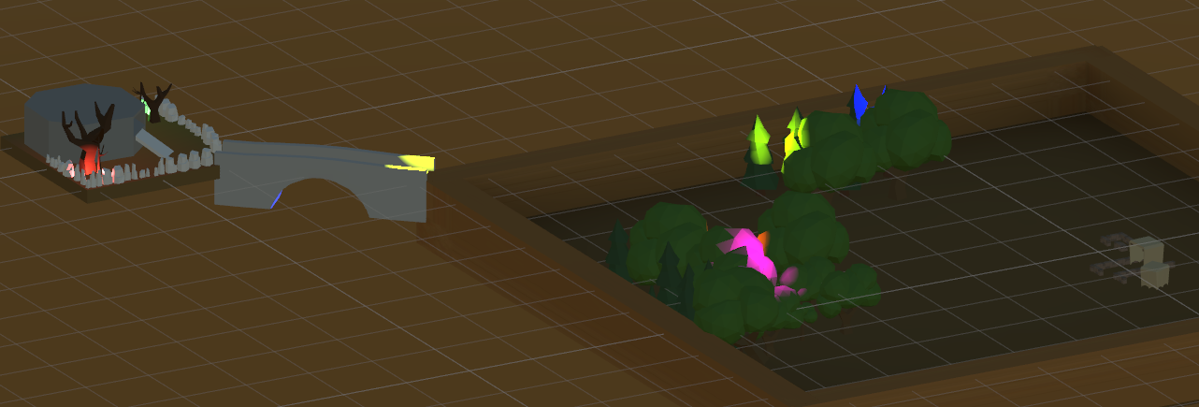

Figure 1 Screenshot #1

## **Task #2. *Add 50 models to map***

Description of the implementation (3-5 sentences).  *I added over 50 models to my map, some of these were made by me and some of these were downloaded from free asset stores like itch.io*



Figure 2. Models #1

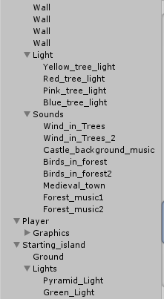

## **Task #3. *Add 10 light sources to map***

Description of the implementation (3-5 sentences). *I added 10 different light sources to my map. All of these light sources are point lights with different intensity and colors.*

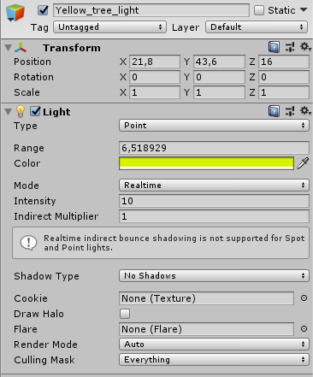

Figure 3. Light #1

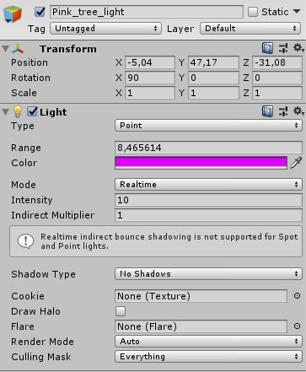

Figure 4 Light #2

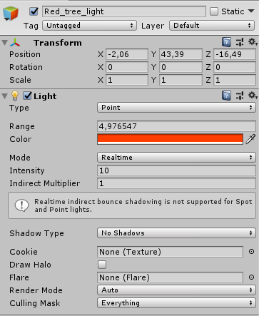

Figure 5 Light #3

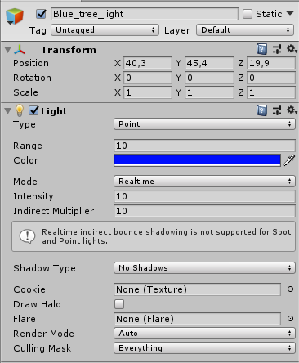

Figure 6 Light #4

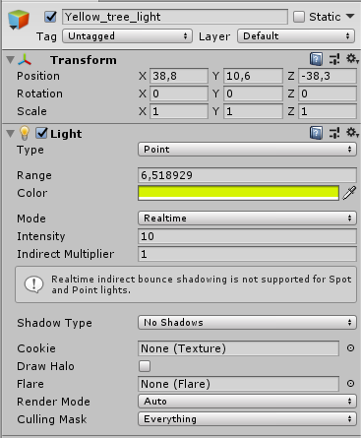

Figure 7 Light #5

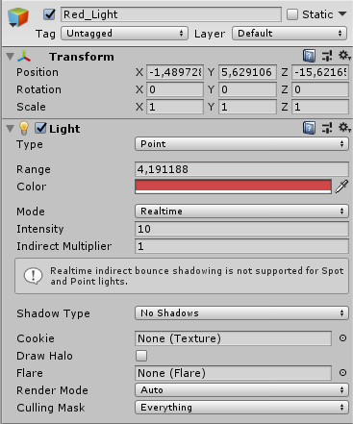

Figure 8 Light #6

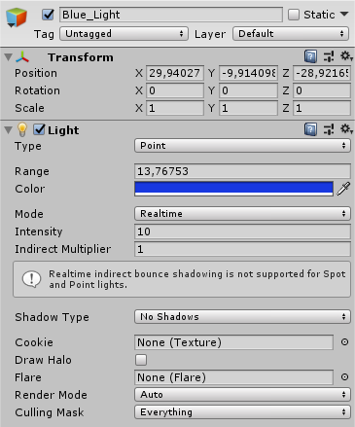

Figure 9 Light #7

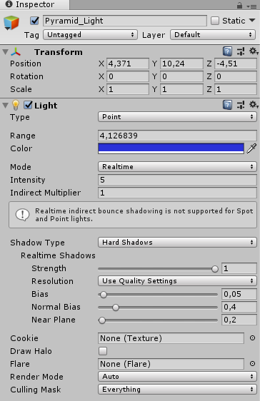

Figure 10 Light #8

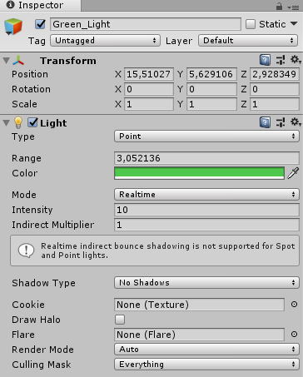

Figure 11 Light #9

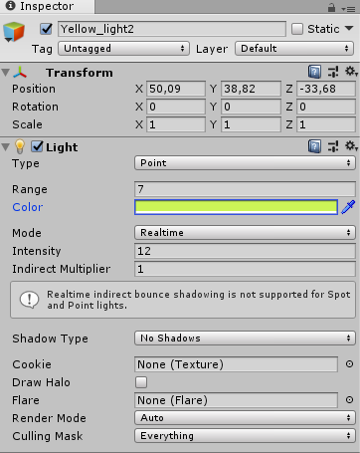

Figure 12 Light #10

## **Task #4. *Add atleast 10 sounds and 5 background music***

Description of the implementation (3-5 sentences). *Firstly I searched for royalty free sound effects on different sites, then I downloaded some background music. After that, I created some audio player components and added them to my map.*

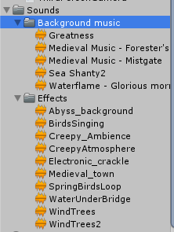

Figure 13. Screenshot #3

## **Task #5. *Add atleast 20 different materials***

Description of the implementation (3-5 sentences).  *I added around 20 different materials to my map and placed them on different objects*



Figure 14 Screenshot #1

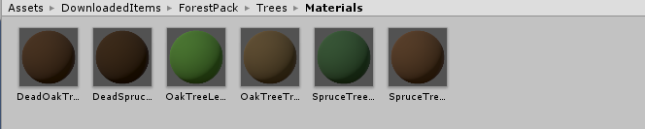

Figure 15 Materials #1

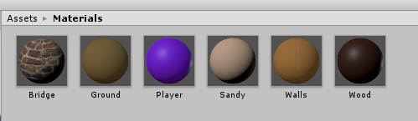

Figure 16 Materials #2

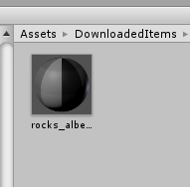

Figure 17 Materials #3

# **Defence task**

Color a plane into two areas with two different lights.

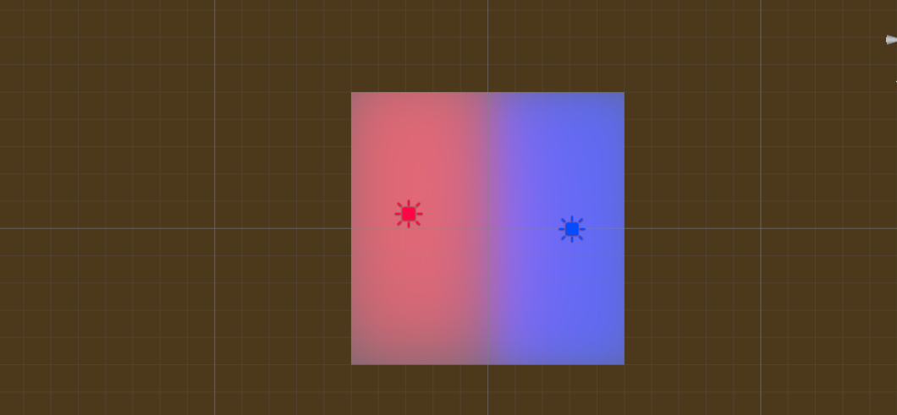

Figure 18 Defense task completed

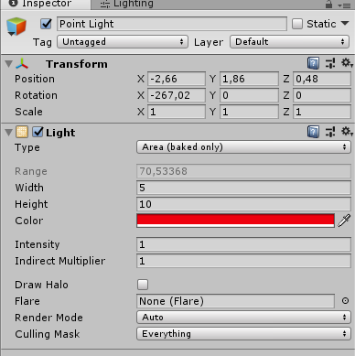

Figure 19 Defense task light

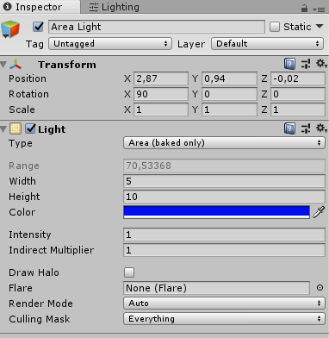

Figure 20 Defense task light #2

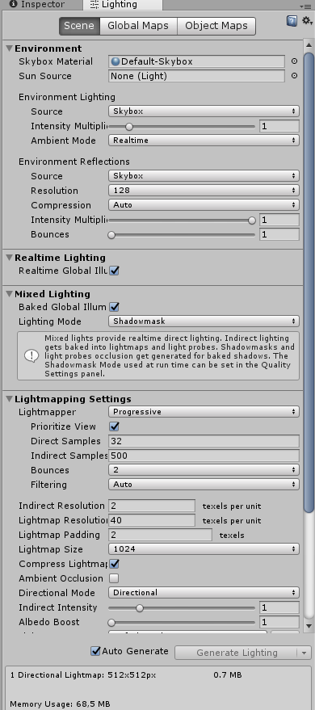

Figure 21 Defense task light settings

# **Laboratory work #2**

List of tasks (main functionality of your project)

1. Create a terrain and color it using 5 or more materials of your own design;
2. Create 5 trees of your own construction and seed them using terrain tools;
3. IMPORT a unique model and assign it to a third person character controller;
4. Add and animate 5 obejcts to your game maps
5. Create 5 unique (non-factory) particle effects (fire, portal, etc.);
6. Add a CUSTOM SKYBOX
7. Create 5 different physics materials and apply them in your project
8. Assign an optimum collider based on the shape of the object for all 3D objects imported in the first laboratory work;
9. Add and animate 5 objects using PHYSICS, FORCE and TRIGGERS to your game maps (traps, falling objects, moving doors, etc.)
10. Set static flag to all immobile objects and measure batching performance;
11. Try deferred vs forward rendering and measure performance for both;
12. Bake a lightmap for your scene and measure performance;
13. Optimize all textures depending on their parameters and measure graphical memory load;
14. Try hard vs soft shadows, different quality settings and measure the performance;

# **Solution**

## **Task #1. *Create a terrain and color it using 5 or more materials of your own design***

Description of the implementation (3-5 sentences).  *Firstly, I added a new terrain objects. Then I reshaped it, added some mountains and painted it with textures using the default tools provided in unity editor.*

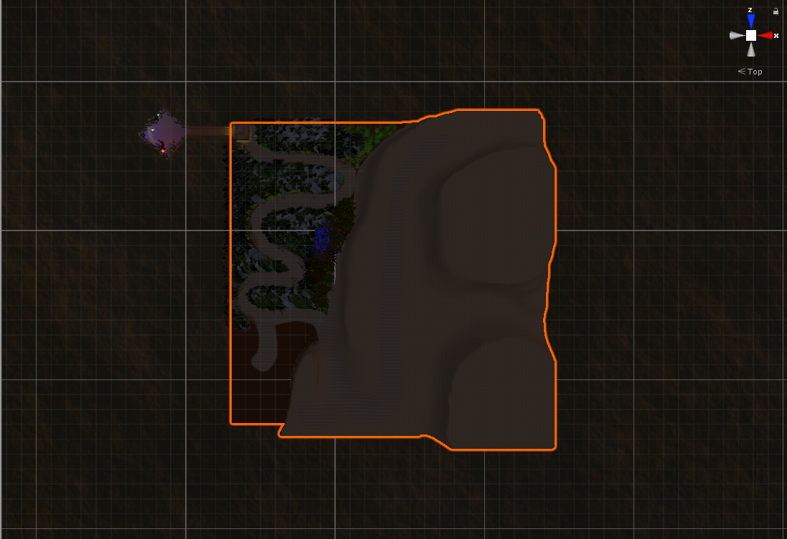

Figure 22 Screenshot of terrain from above

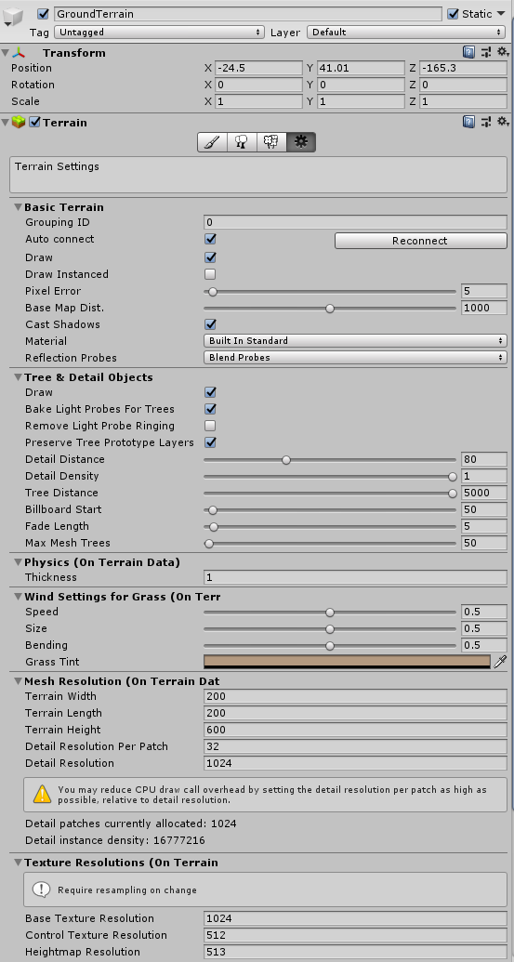

Figure 23 Terrain parameters

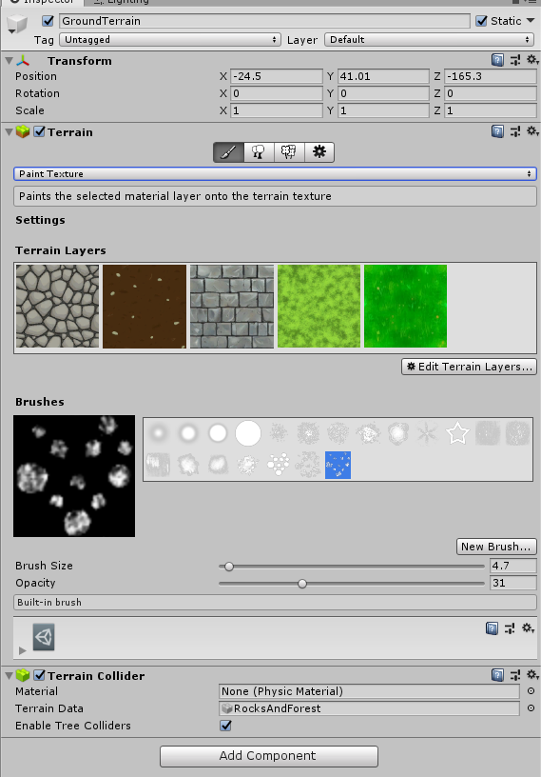

Figure 24 Materials used to colour the terrain

## **Task #2. *Create 5 trees of your own construction and seed them using terrain tools***

Description of the implementation (3-5 sentences).  *Firstly, I created 5 unique trees, added some branches and leaves to each one of them, then added a few different materials and capsule colliders to all of them. Then using the terrain feature called “Paint trees”, I quickly added a lot of tress to my terrain to make it look more live.*

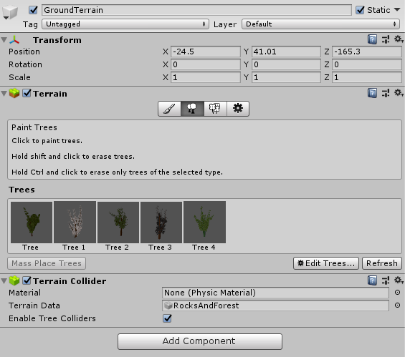

Figure 25 Trees used in Tree painting

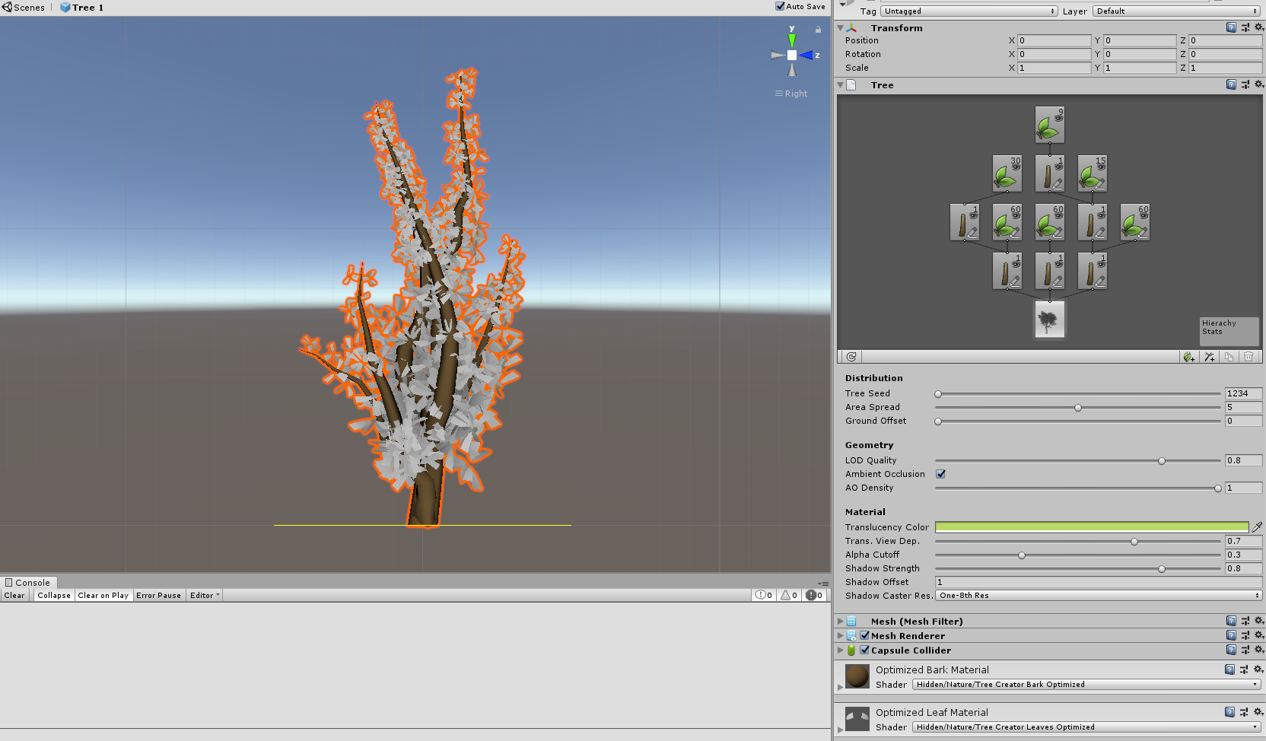

Figure 26 Structure of tree #1

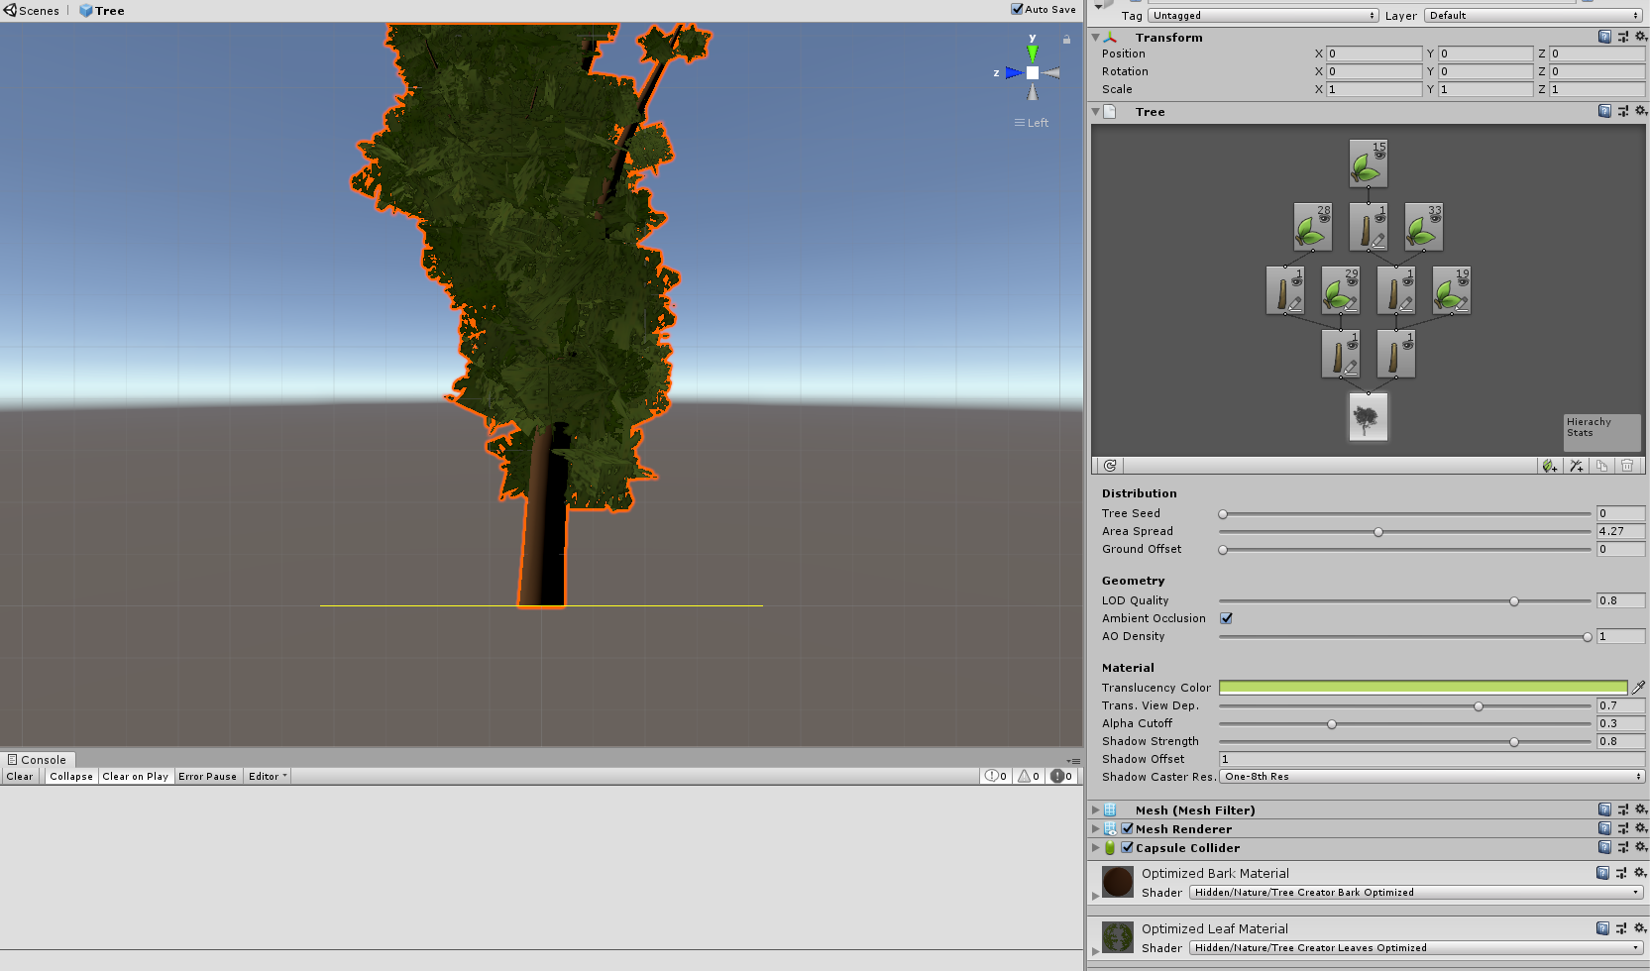

Figure 27 Structure of tree #2

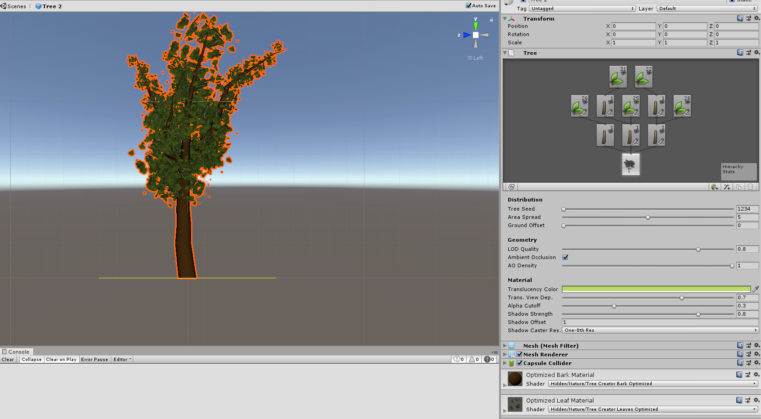

Figure 28 Structure of tree #3

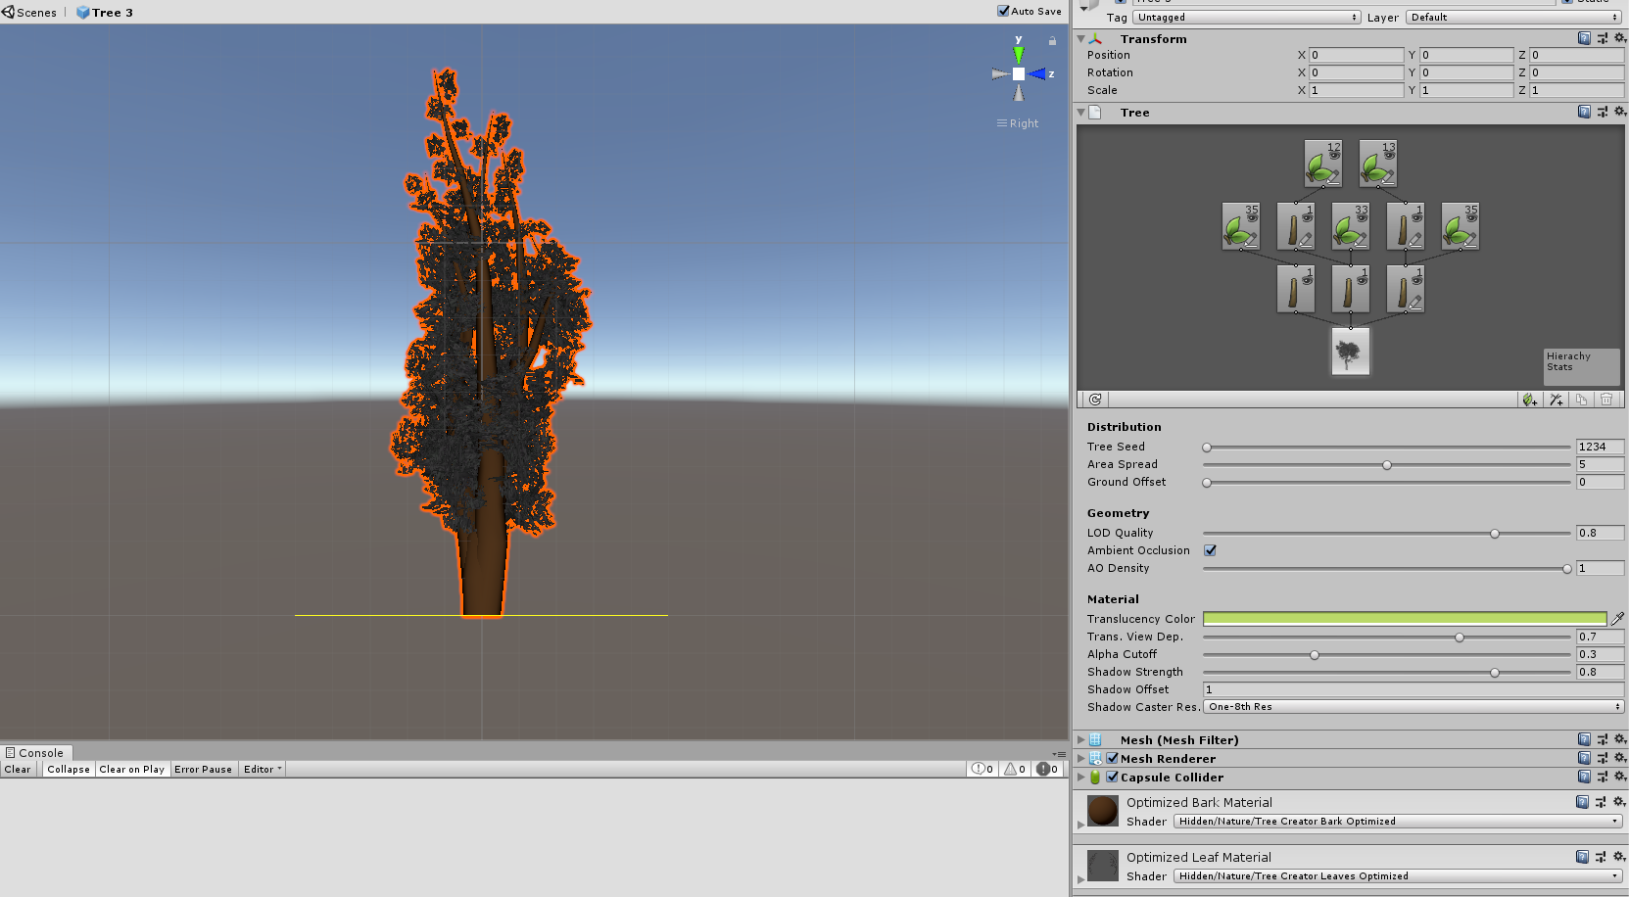

Figure 29 Structure of tree #4

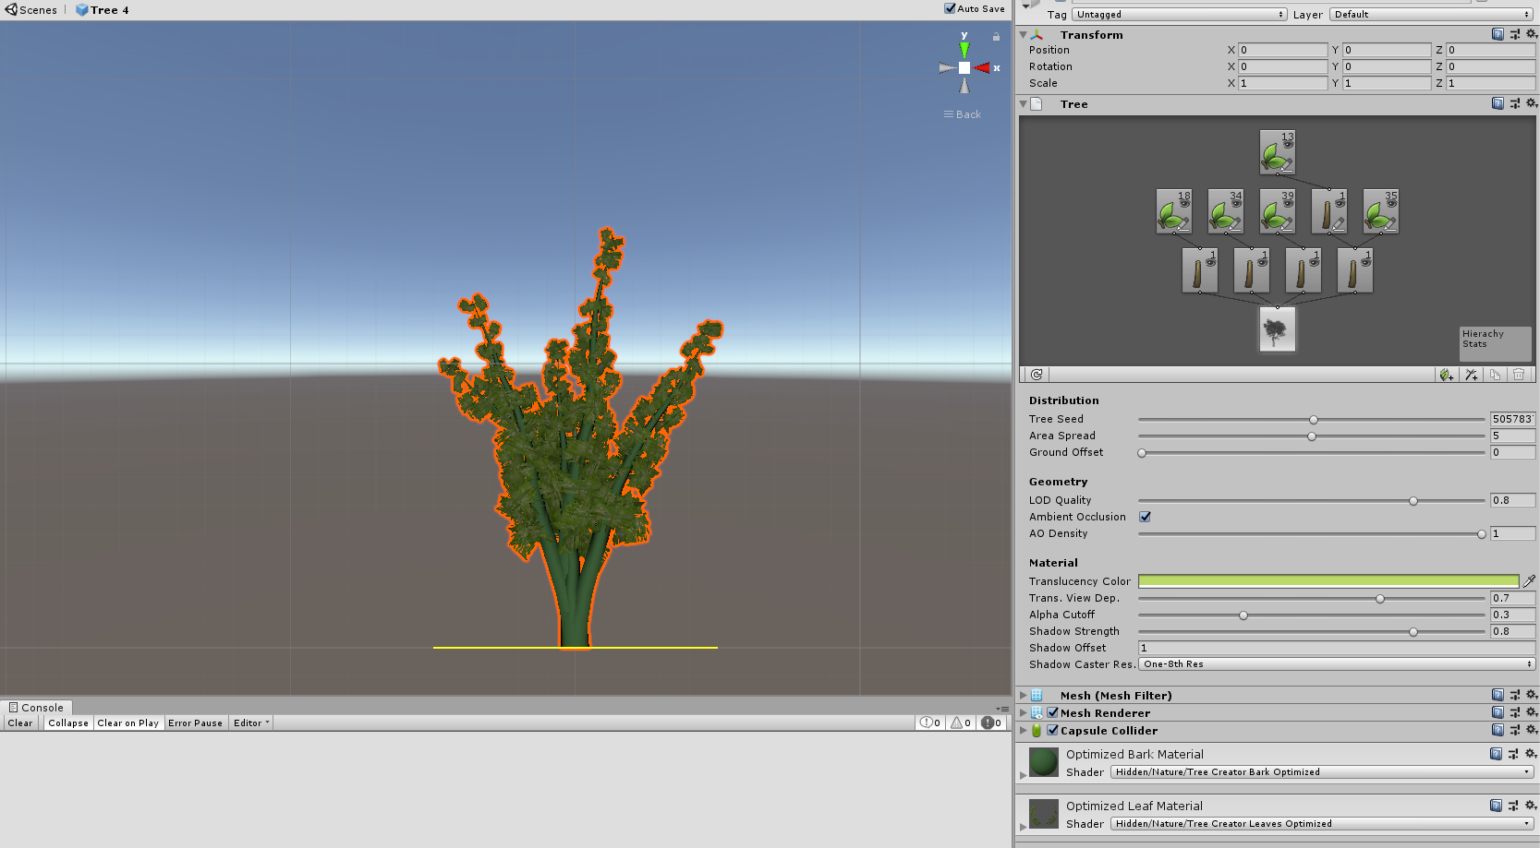

Figure 30 Structure of tree #5

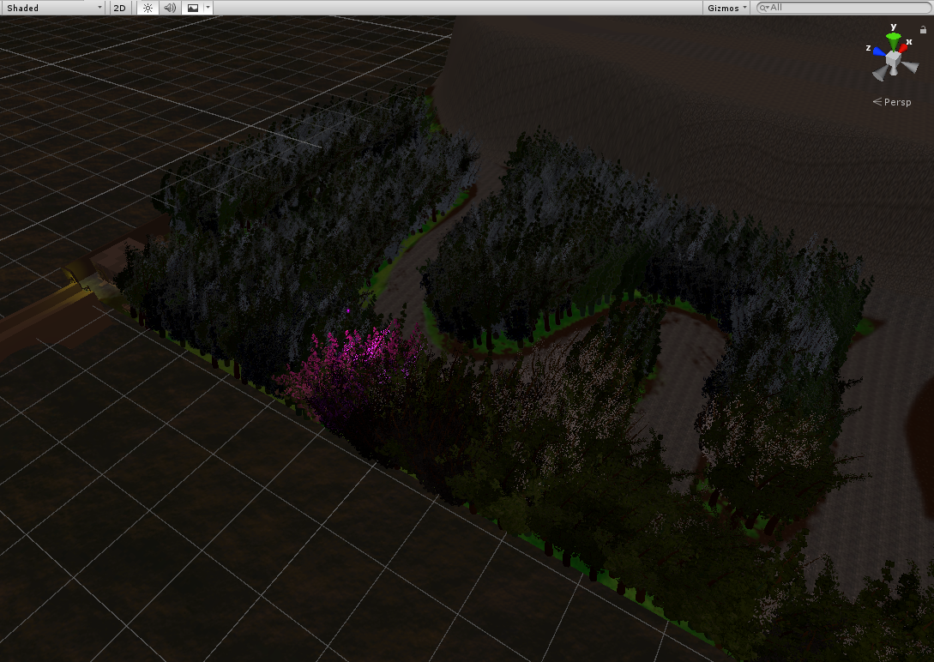

Figure 31 Forest created using Paint trees tool

## **Task #3. *IMPORT a unique model and assign it to a third person character controller***

Description of the implementation (3-5 sentences).  *Firstly, I downloaded Blood mage character from unity asset store. Then I imported it, attached rigid body, third person control and third person character scripts, and capsule collider components to it and checked if the bone structure was working as expected.*

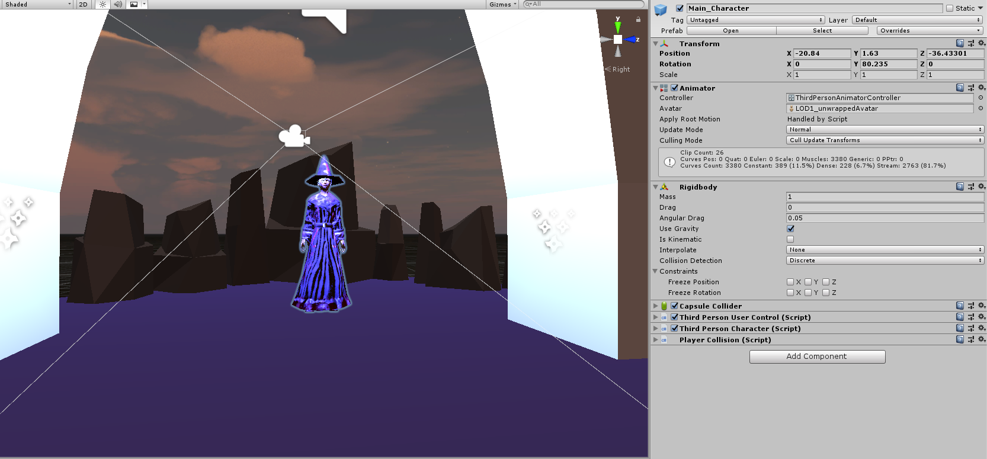

Figure 32 Properties of the main character

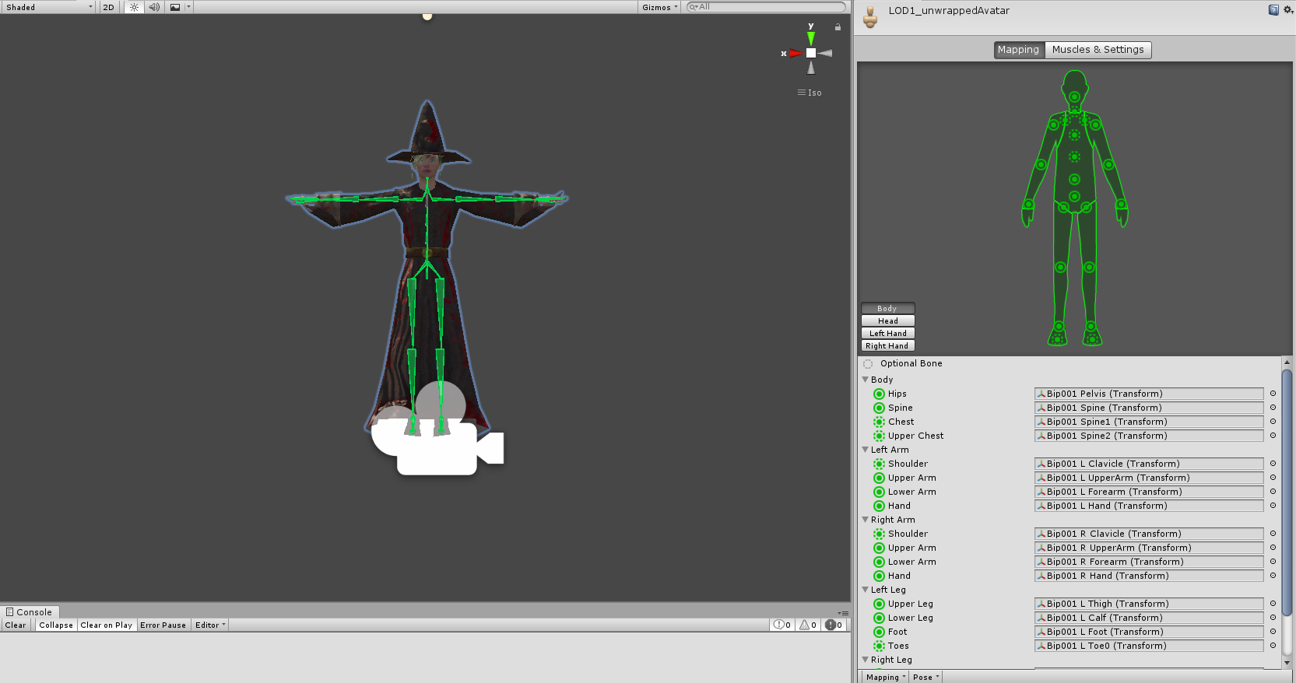

Figure 33 Bone structure of main character

## **Task #4. *Add and animate 5 objects to your game maps***

Description of the implementation (3-5 sentences).  *I added some objects from asset store, attached animators and animation controllers to all of them and then created 5 animations.*

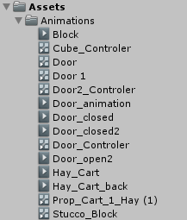

Figure 34 Animation folder

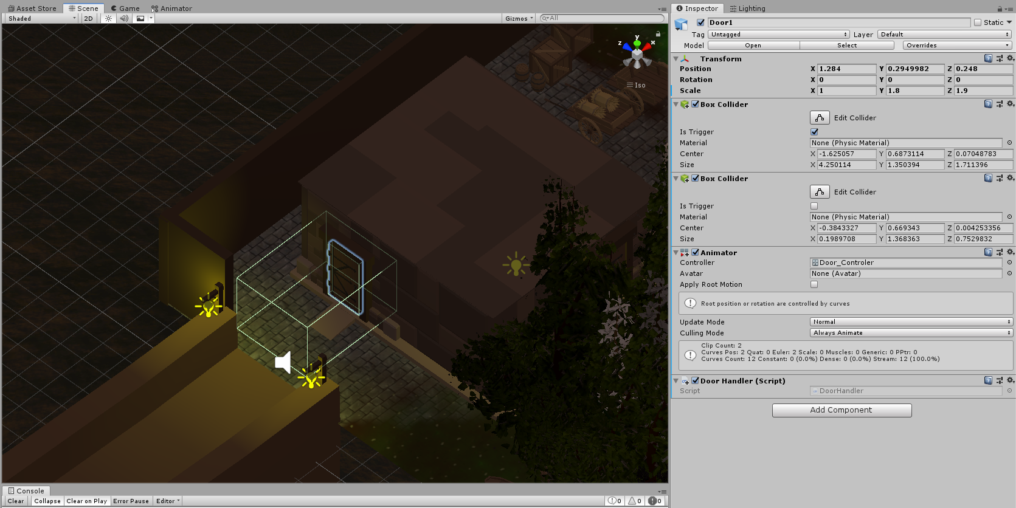

Figure 35 Animated object

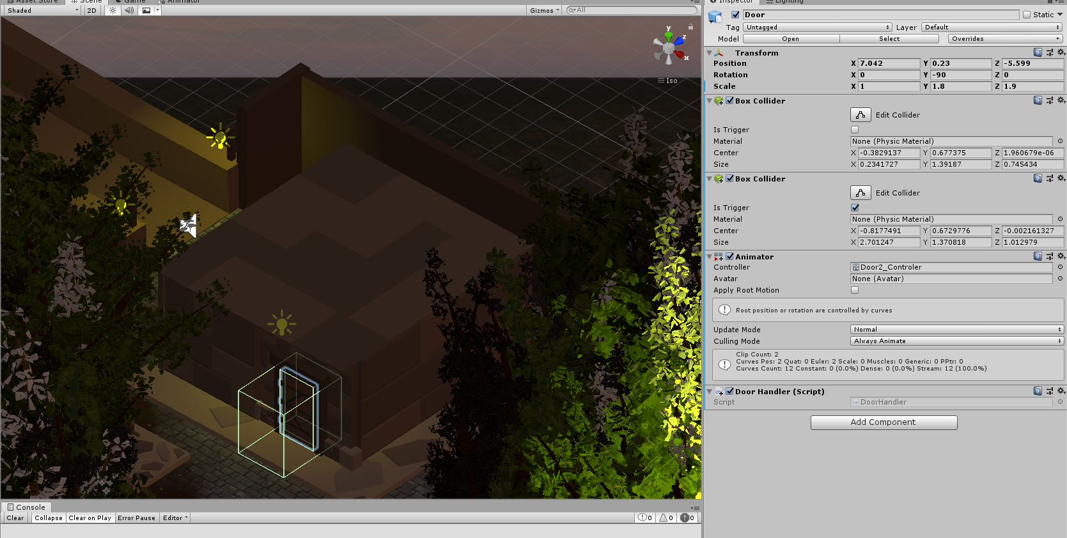

Figure 36 Animated object

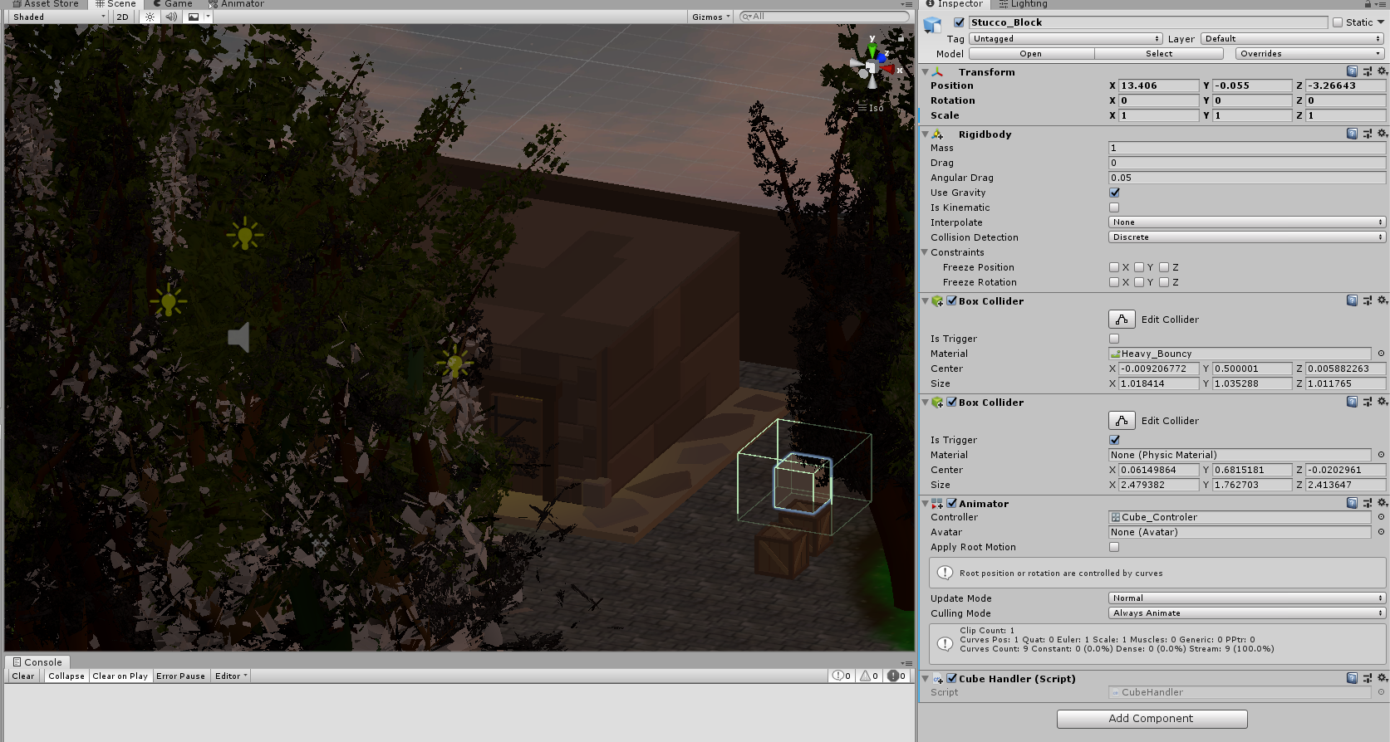

Figure 38 Animated object

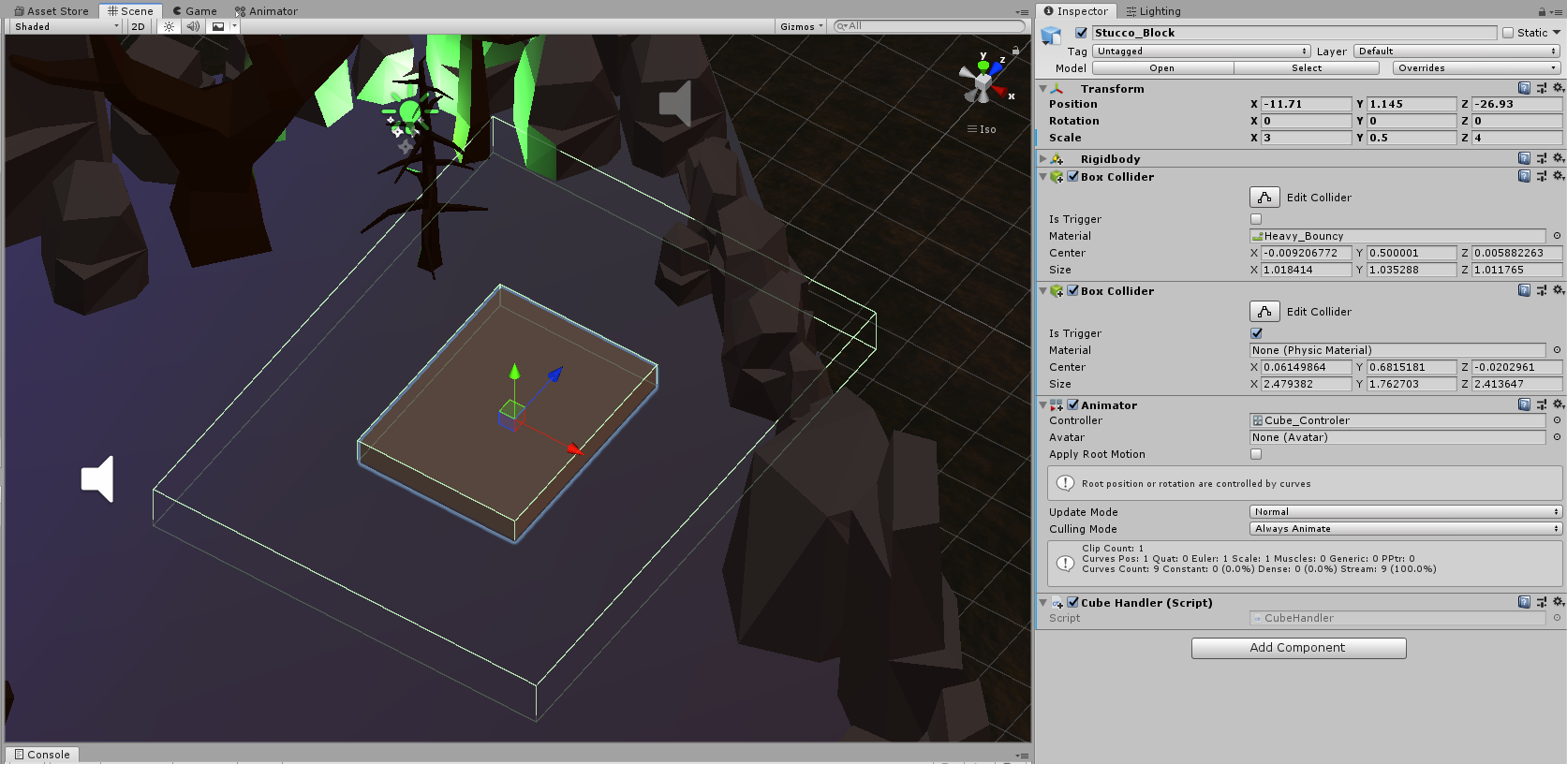

Figure 39 Animated object

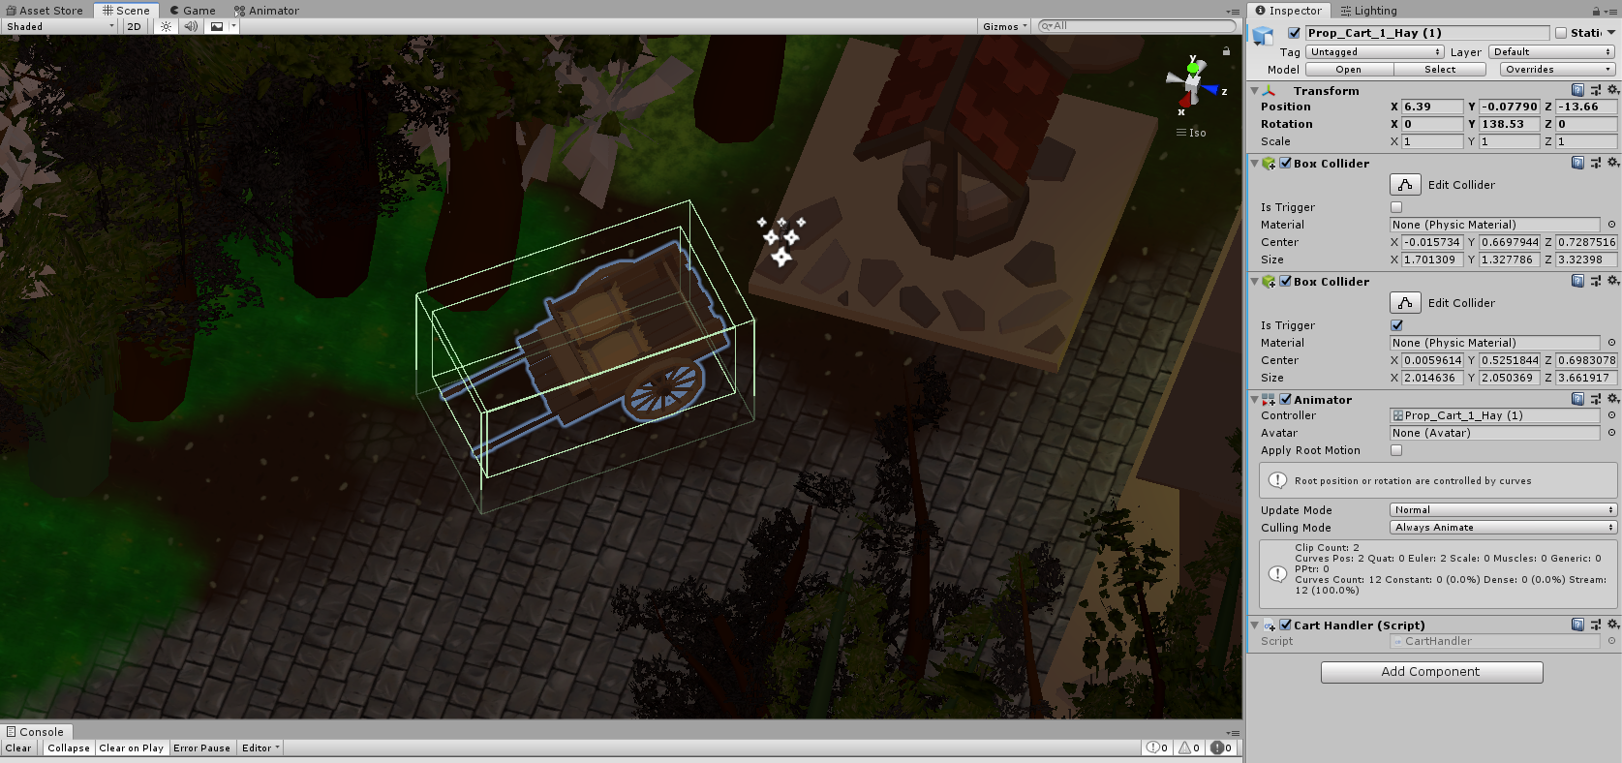

Figure 40 Animated object

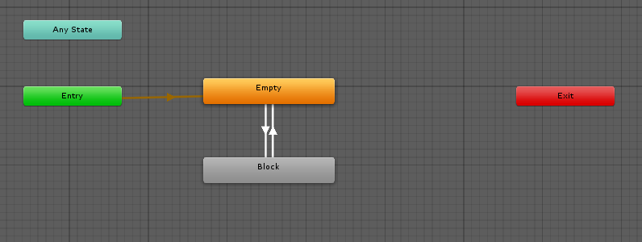

Figure 41 Block animation controller

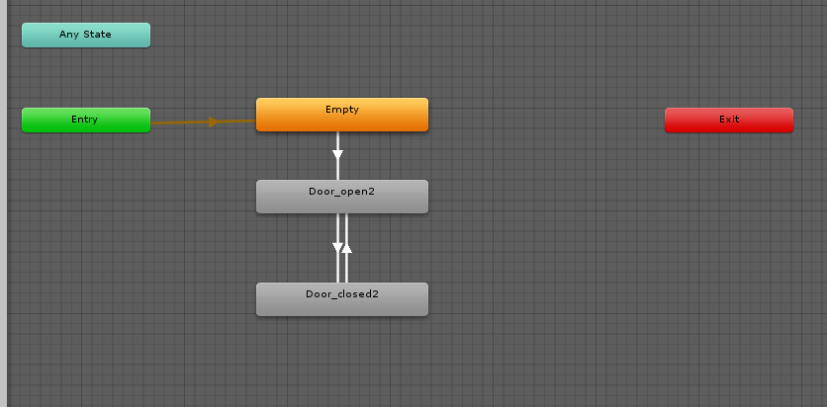

Figure 42 Door 2 animation controller

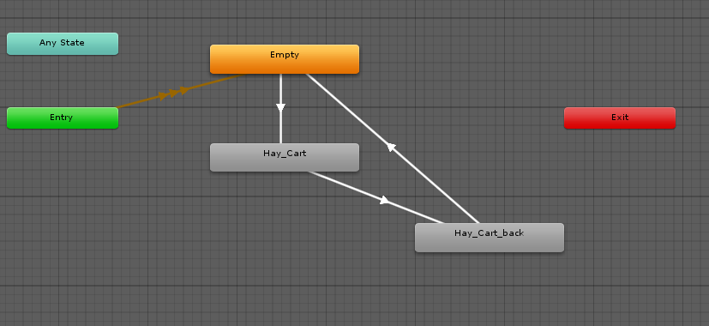

Figure 43 Hay cart animation controller

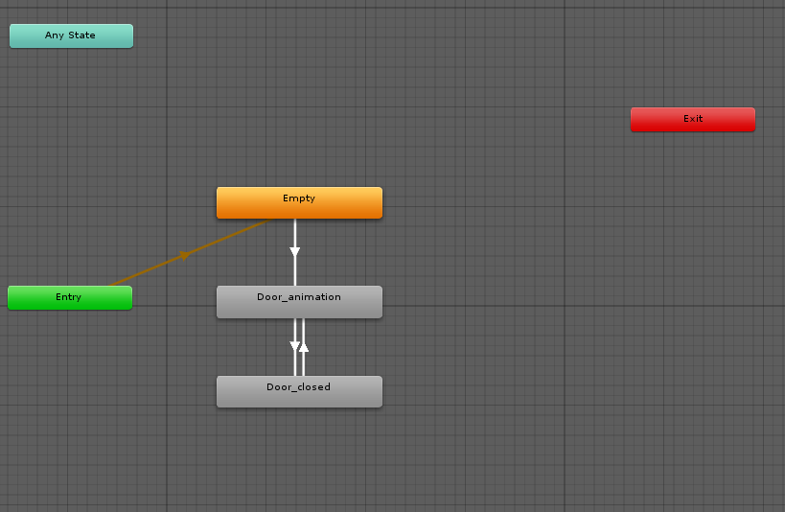

Figure 44 Door animation controller

## **Task #5. *Create 5 unique (non-factory) particle effects***

Description of the implementation (3-5 sentences).  *I created 5 unique particle effects and added them to my map*

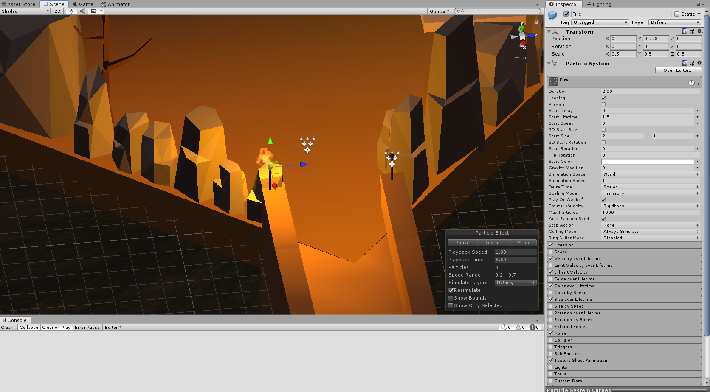

Figure 45 Particle effect #1

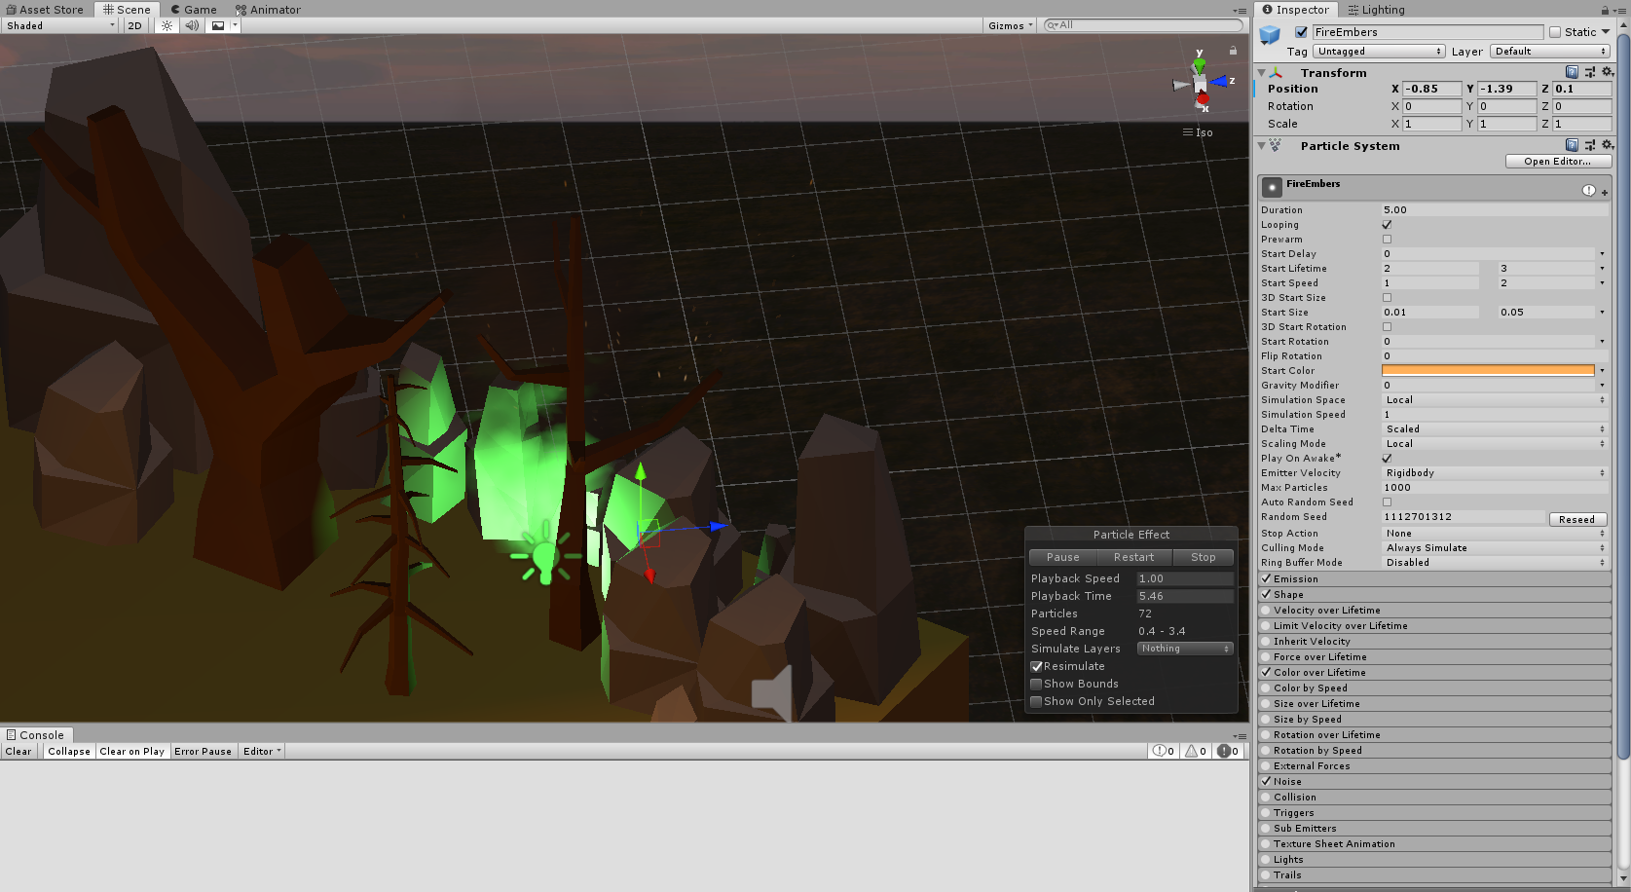

Figure 46 Particle effect #2

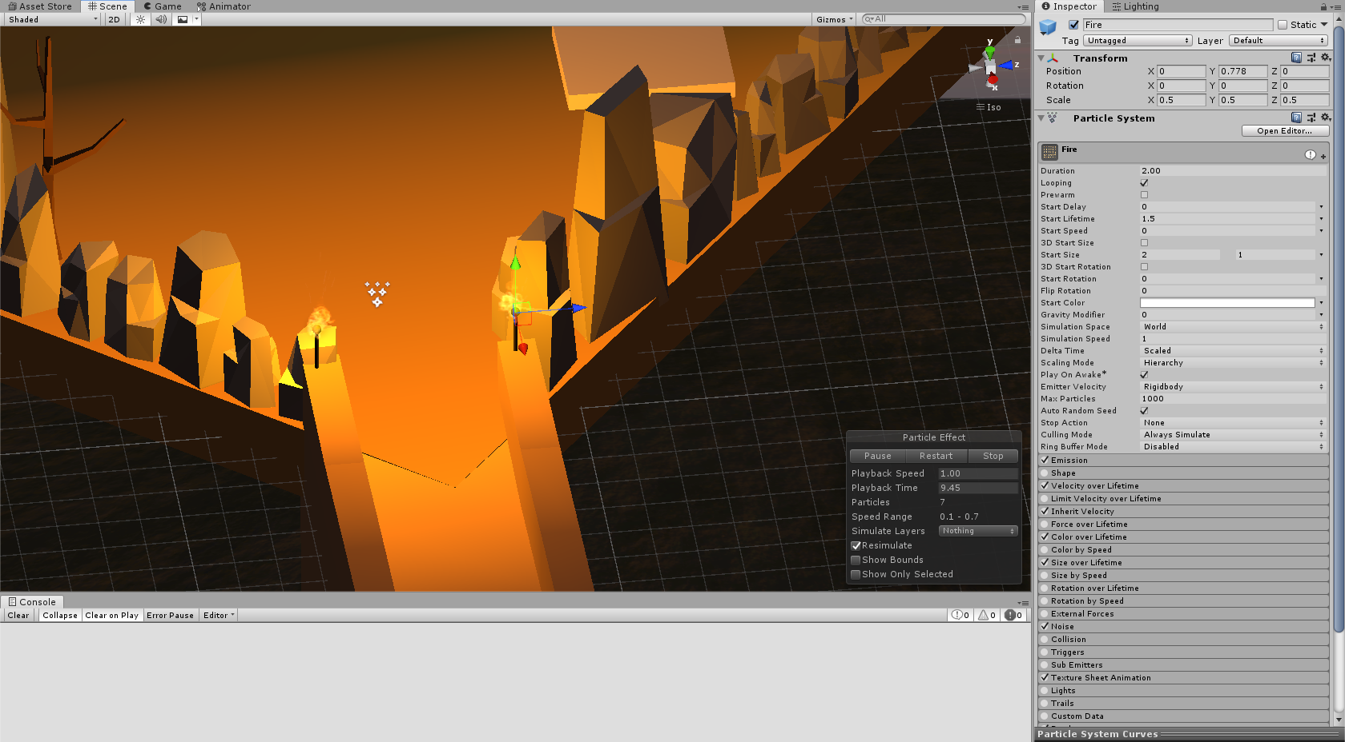

Figure 47 Particle effect #3

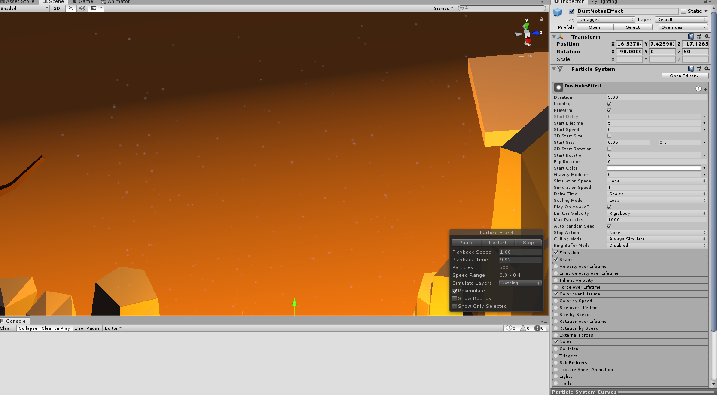

Figure 48 Particle effect #4

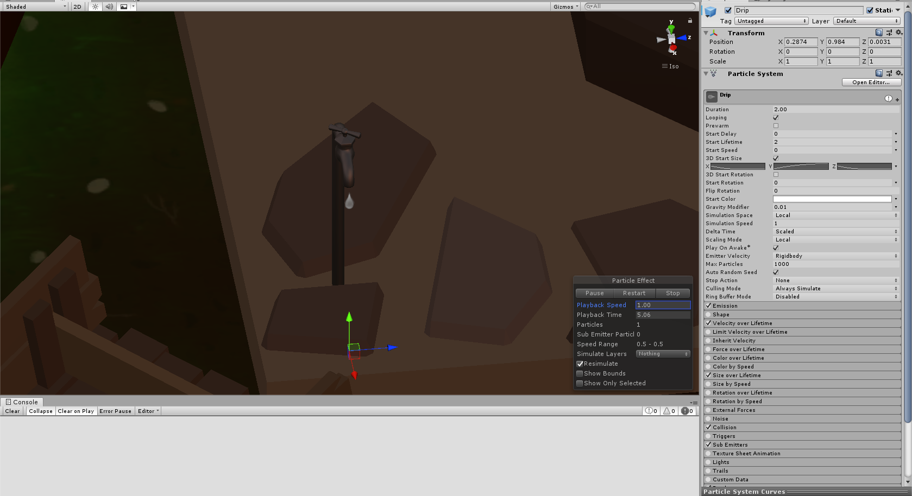

Figure 49 Particle effect #5

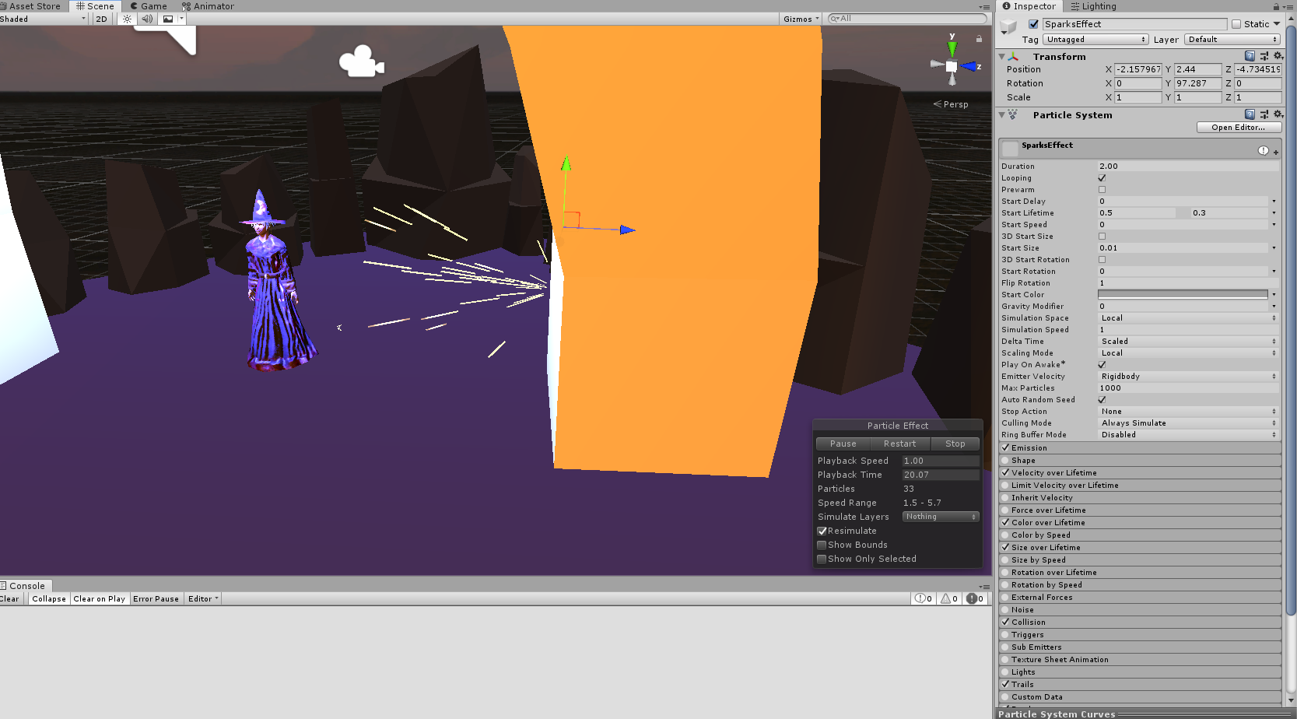

Figure 49 Particle effect #6

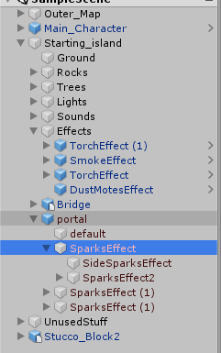

Figure 50 Particle effects

## **Task #6. *Add a CUSTOM SKYBOX***

Description of the implementation (3-5 sentences).  *I downloaded a cube shaped picture and applied it to skybox material.*

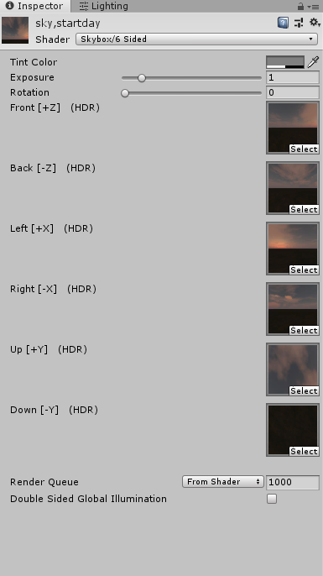

Figure 51 Custom Skybox

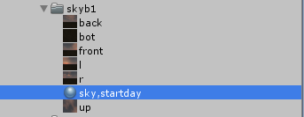

Figure 52 Custom Skybox

## **Task #7. *Create 5 different physics materials and apply them in your project***

Description of the implementation (3-5 sentences).  *I created 5 different physics materials with different properties and applied them to the objects in my scene.*

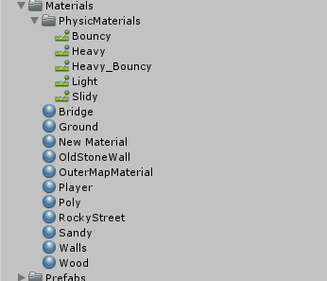

Figure 53 Unique physics materials

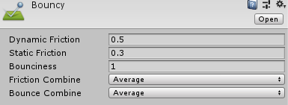

Figure 54 Bouncy physics material

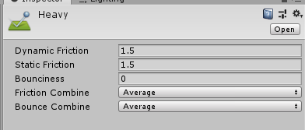

Figure 55 Heavy physics material

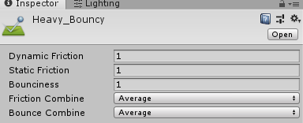

Figure 56 Heavy_Bouncy physics material

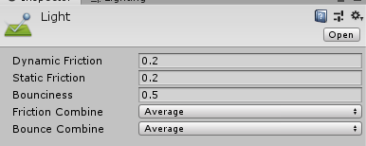

Figure 56 Light physics material

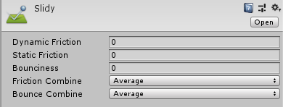

Figure 57 Slidy physics material

## **Task #8. *Assign an optimum collider based on the shape of the object for all 3D objects***

Description of the implementation (3-5 sentences).  *I assigned various colliders to many different objects.*

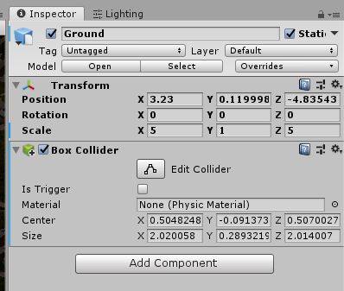

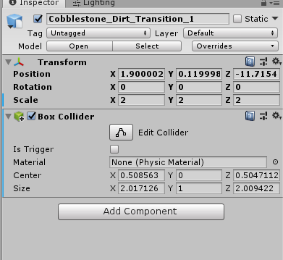

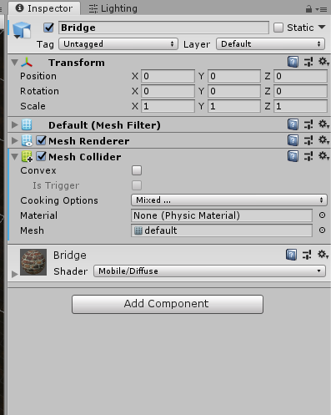

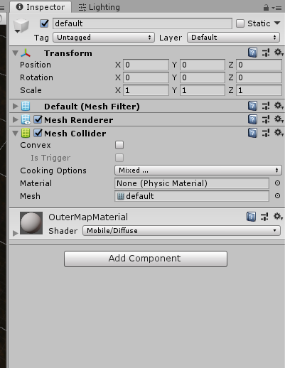

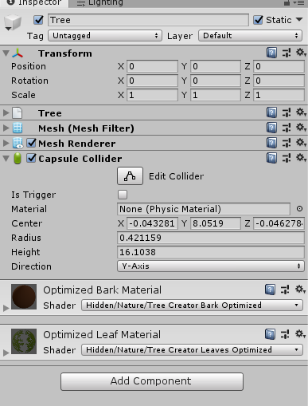

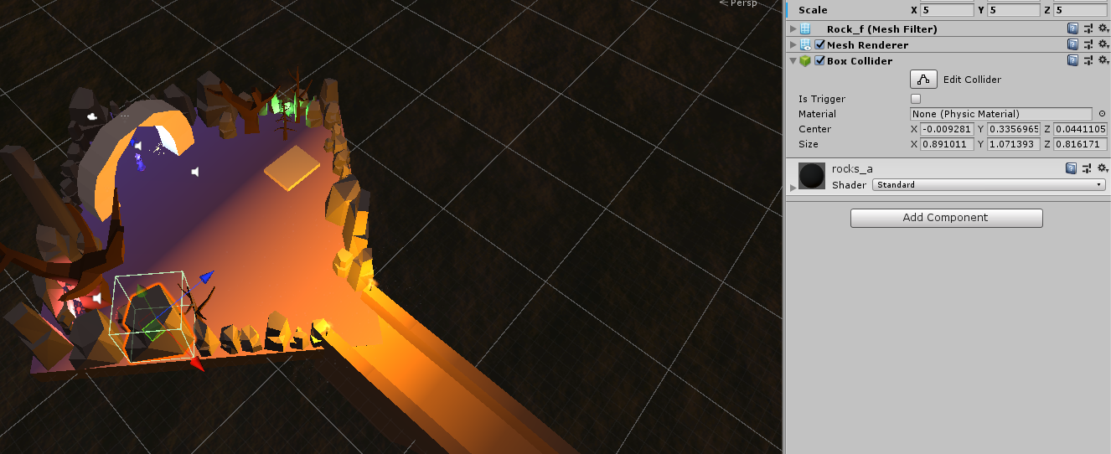

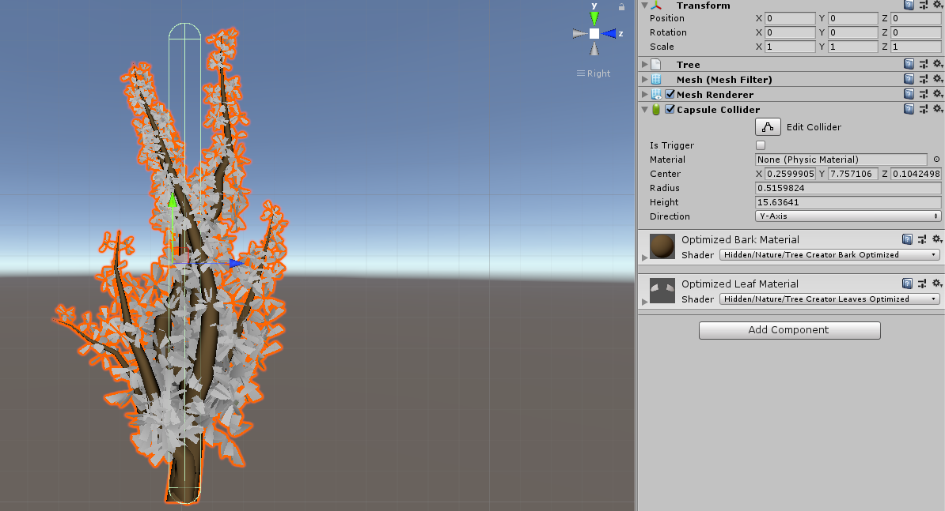

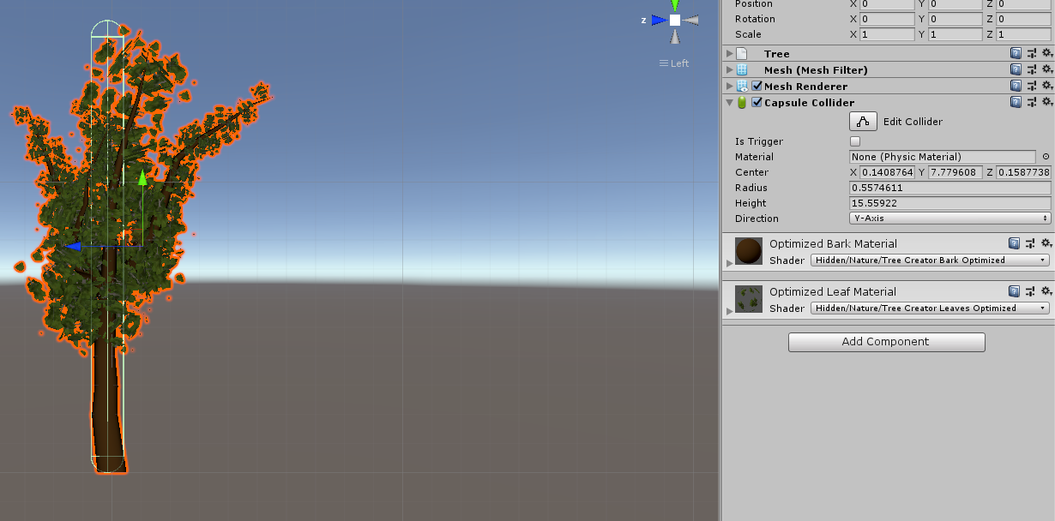

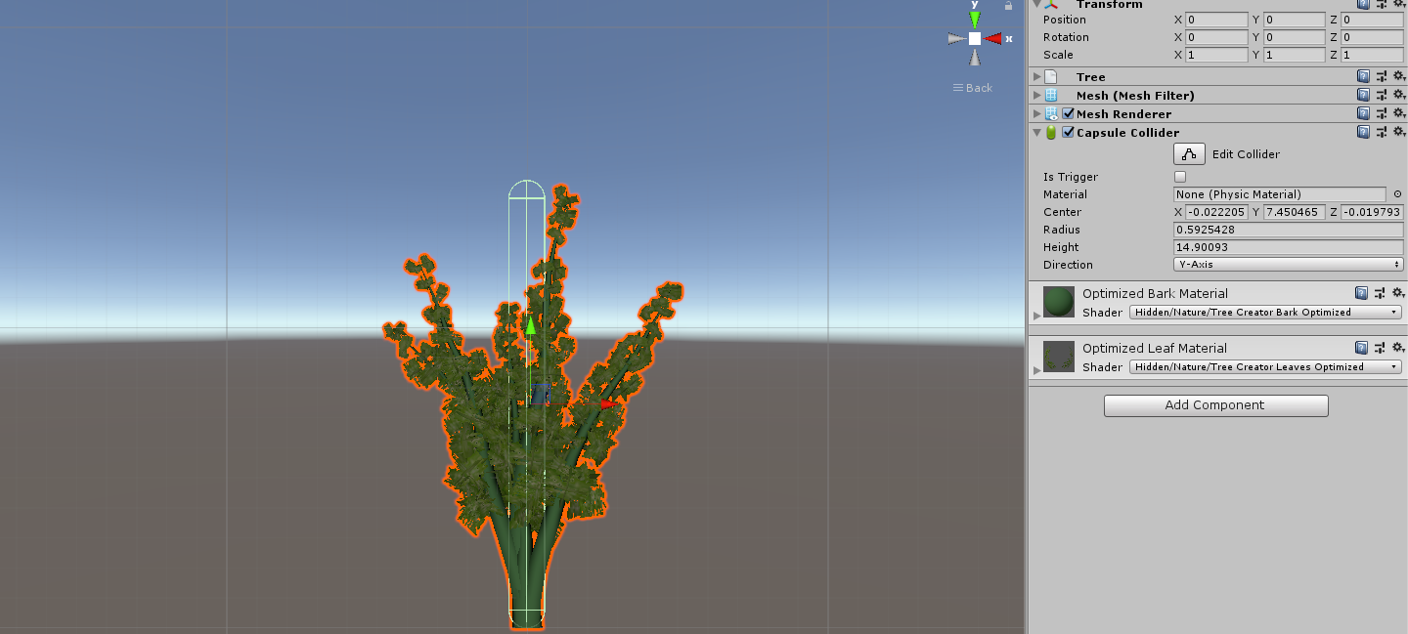

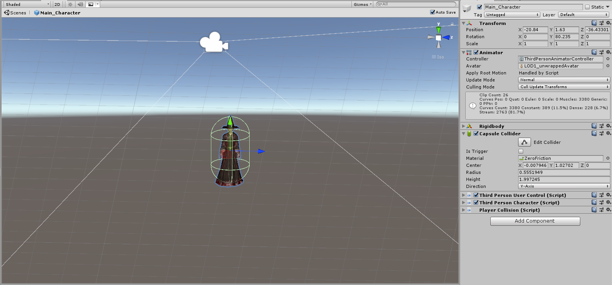

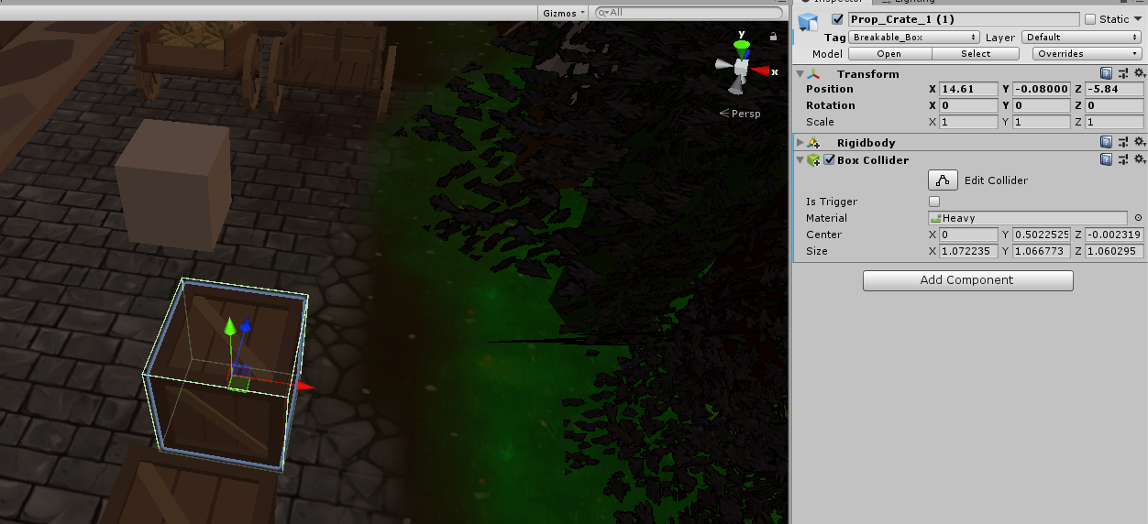

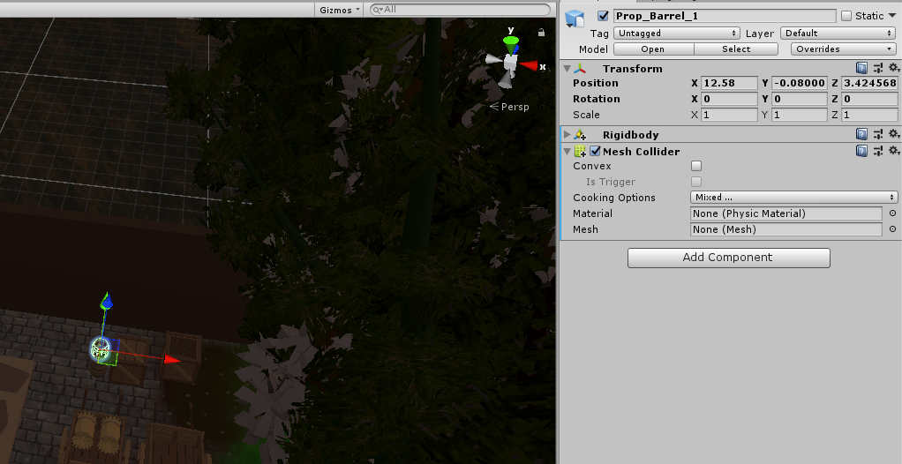

## **Task #9. *Add and animate 5 objects using PHYSICS, FORCE and TRIGGERS***

Description of the implementation (3-5 sentences).  *I added some objects from asset store, attached animators and animation controllers to all of them and then created 5 animations.*



Figure 34 Animation folder



Figure 35 Animated object



Figure 36 Animated object



Figure 38 Animated object



Figure 39 Animated object



Figure 40 Animated object



Figure 41 Block animation controller



Figure 42 Door 2 animation controller



Figure 43 Hay cart animation controller



Figure 44 Door animation controller

## **Task #10. *Set static flag to all immobile objects and measure batching performance***

Description of the implementation (3-5 sentences).  *I set static flags on all immobile objects. Making all objects static increased memory costs and building and batching time, but improved performance at runtime.*

**Task #11. *Try deferred vs forward rendering and measure performance for both***

Description of the implementation (3-5 sentences).  *I measured the performance when using deferred vs forward rendering method. Deferred rendering method is better when there are a lot of lights in scene, as the performance doesn’t change, while if you have only 1 light, using deferred method can hurt performance. Also deferred method can’t render transparent objects.*

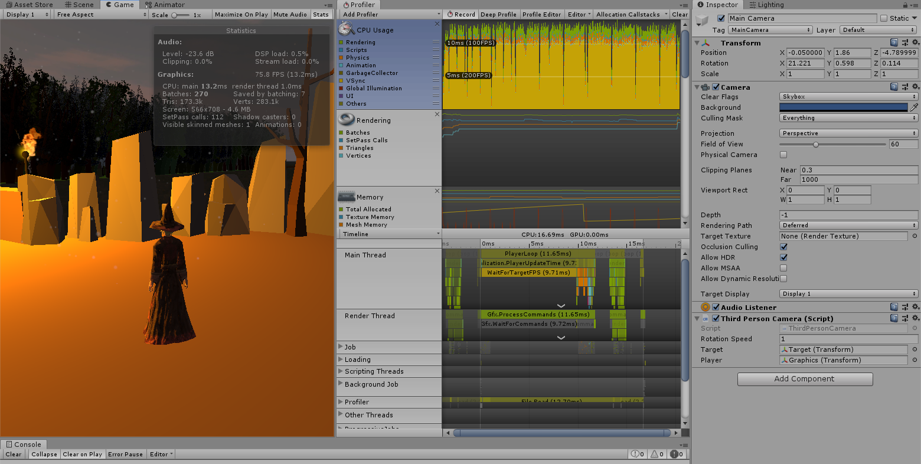

Figure 45 Performance when using deferred rendering method

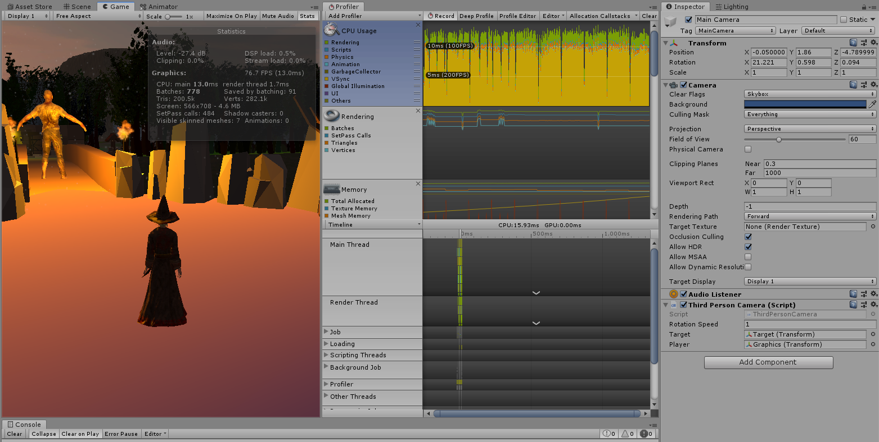

Figure 46 Performance when using forward rendering method

**Task #12. *Bake a lightmap for you scene and measure performance***

Description of the implementation (3-5 sentences).  *I turned lightmap baking on and set all lights to baked mode and instantly saw that my computer slowed down quite a bit while baking the lightmap, and it took a couple of minutes. I didn’t really see that big of a difference because I don’t use that much lights, but the slowdown while baking is quite noticeable.*



Figure 47 Lightmap baking time

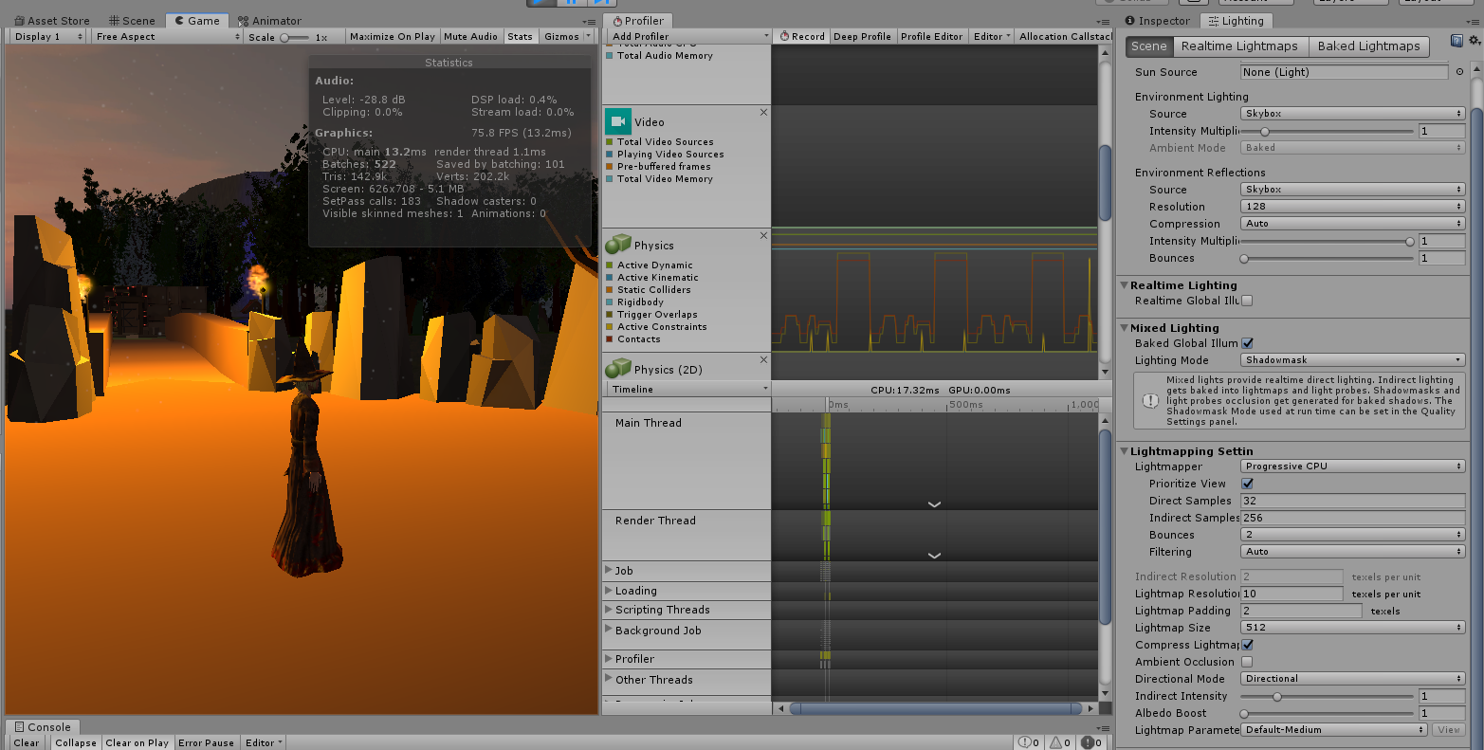

Figure 47 Performance when using baked lights and lightmap baking

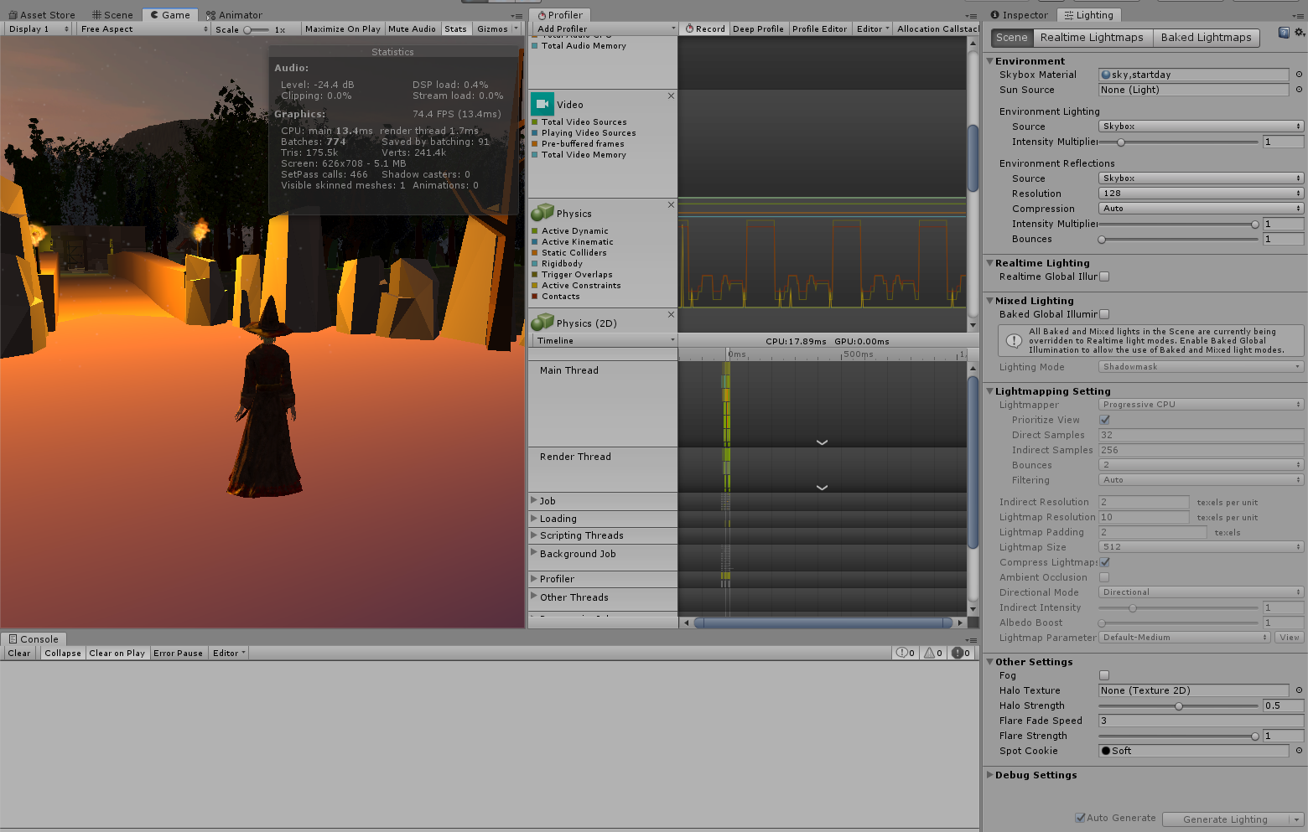

Figure 48 Performance when NOT using baked lights and lightmap baking

**Task #13. *Optimize all textures depending on their parameters and measure graphical memory load***

Description of the implementation (3-5 sentences).  *I turned on mipmaps on all textures. Performance wise it is useful to use mip maps on any 3D game as they make distant objects look better and use way less GPU memory.*

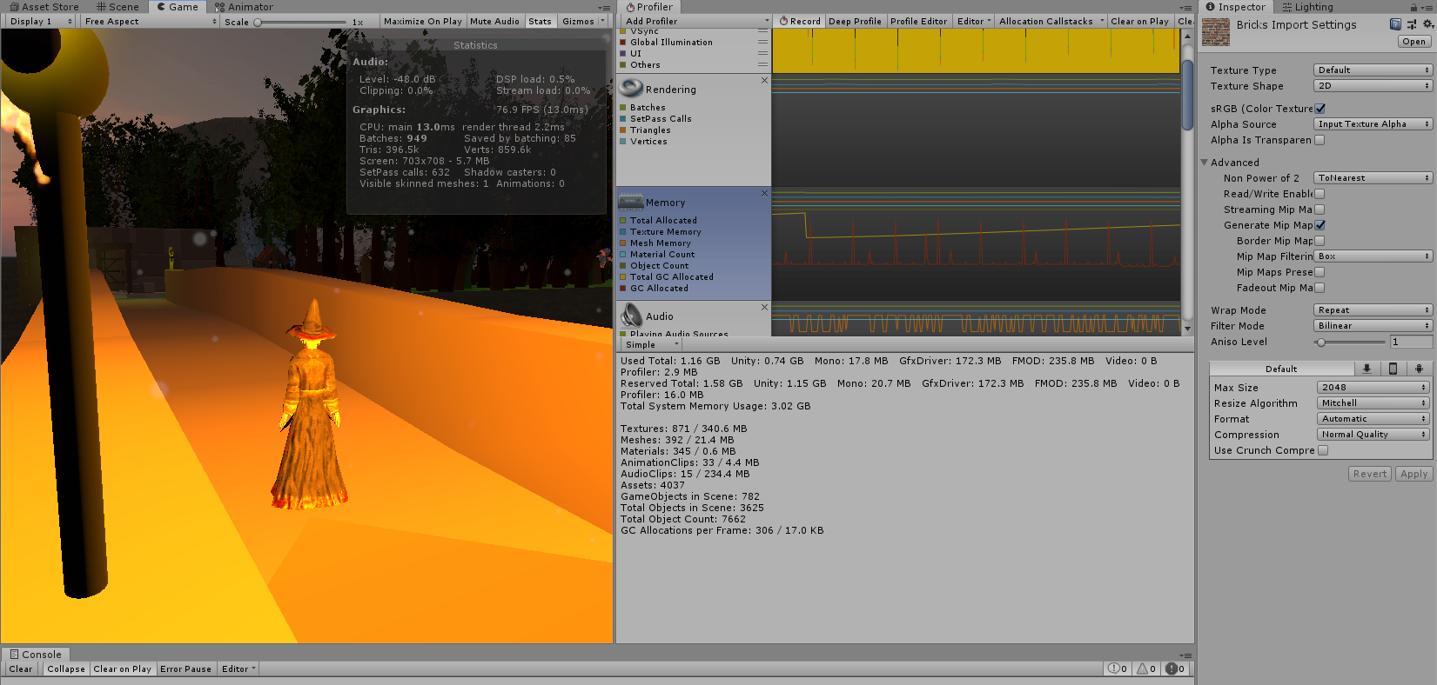

Figure 49 Used memory on textures

**Task #13. *Try hard vs soft shadows, different quality settings and measure the performance***

Description of the implementation (3-5 sentences).  *Firstly I turned all shadows to ultra quality soft and measured the performance, and then I did the same thing for hard shadows. The difference in performance between them wasn’t noticeable for me as I do not use lots of lights and my system is fairly powerful, but for older or weaker systems, turning down shadow resolution can change the performance drastically for the better.*

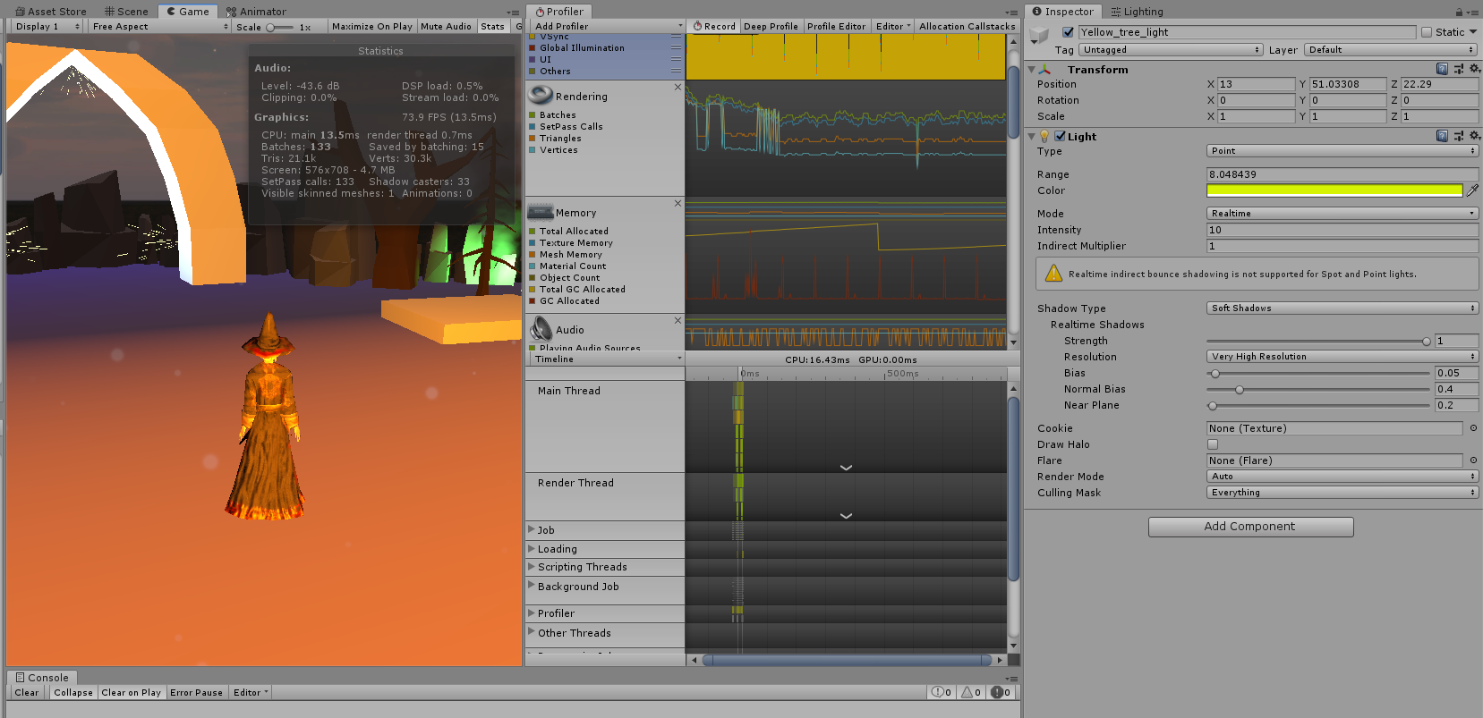

Figure 49 Performance while using ultra quality soft shadows

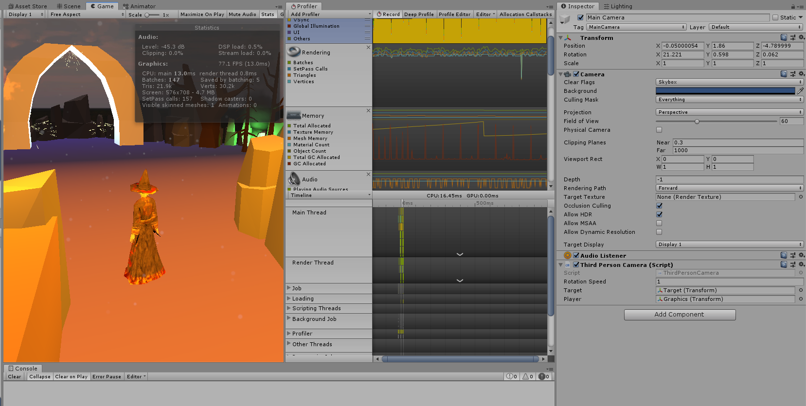

Figure 50 Performance while using hard shadows

# **Literature list**

1. Source #1. [*https://freesound.org/*](https://freesound.org/)
2. Source #2. <https://www.youtube.com/watch?v=7nxpDwnU0uU&list=PLrbglElPxW9KvfHztR-8UcZUX0h4jwdgE&index=2&t=0s>
3. Source #3 <https://www.youtube.com/watch?v=JYj6e-72RDs&index=2&list=PLrbglElPxW9KvfHztR-8UcZUX0h4jwdgE>
4. Source #4 <https://www.youtube.com/watch?v=Wql4nZkqG0g&list=PLrbglElPxW9KvfHztR-8UcZUX0h4jwdgE&index=3>
5. Source #5 <https://www.youtube.com/watch?v=69AlA-i1hIU&index=4&list=PLrbglElPxW9KvfHztR-8UcZUX0h4jwdgE>

# **ANNEX**

All source code is contained in this part.

using System.Collections;

using System.Collections.Generic;

using UnityEngine;

public class PlayerCollision : MonoBehaviour

{

void OnCollisionEnter(Collision collision)

{

//Debug.Log("OOOOOOOOOOOOOOF");

if (collision.gameObject.tag == "Breakable_Box")

{

//Debug.Log("x22x2x2x2");

Destroy(collision.gameObject);

}

}

}

using System.Collections;

using System.Collections.Generic;

using UnityEngine;

public class CubeHandler : MonoBehaviour

{

private Animator animator;

// Start is called before the first frame update

void Start()

{

animator = GetComponent<Animator>();

animator.SetBool("isNear", false);

}

// Update is called once per frame

void Update()

{

}

void OnTriggerEnter(Collider collider)

{

animator.SetBool("isNear", true);

}

void OnTriggerExit(Collider collider)

{

animator.SetBool("isNear", false);

}

}

using System.Collections;

using System.Collections.Generic;

using UnityEngine;

public class DoorHandler : MonoBehaviour

{

private Animator animator;

// Start is called before the first frame update

void Start()

{

animator = GetComponent<Animator>();

animator.SetBool("isOpen", false);

}

// Update is called once per frame

void Update()

{

}

void OnTriggerEnter(Collider collider)

{

animator.SetBool("isOpen", true);

}

void OnTriggerExit(Collider collider)

{

animator.SetBool("isOpen", false);

}

}

using System.Collections;

using System.Collections.Generic;

using UnityEngine;

public class PlayerControler : MonoBehaviour

{

Camera cam;

public float speed;

private Rigidbody rb;

void Start()

{

cam = Camera.main;

rb = GetComponent<Rigidbody>();

}

void FixedUpdate()

{

//Debug.Log("x: " + rb.velocity.x + " y: " + rb.velocity.y + " z: " + rb.velocity.z);

Vector3 v = new Vector3(0.0f, rb.velocity.y, 0.0f);

rb.velocity = v;

float moveHorizontal = Input.GetAxis("Horizontal");

float moveVertical = Input.GetAxis("Vertical");

Vector3 movement = new Vector3(moveHorizontal, 0, moveVertical);

//rb.velocity = movement * speed;

rb.AddRelativeForce(movement * speed);

}

//Camera cam;

//public float Speed = 10f;

//Vector3 movement = new Vector3();

//Rigidbody rb3D;

//private void Start()

//{

// cam = Camera.main;

// rb3D = GetComponent<Rigidbody>();

//}

//void FixedUpdate()

//{

// GetInput();

// MoveCharacter(movement);

//}

//private void GetInput()

//{

// movement.x = Input.GetAxisRaw("Horizontal");

// movement.y = 0f;

// movement.z = Input.GetAxisRaw("Vertical");

// Debug.Log("x: "+movement.x +" y: "+movement.y +" z: " +movement.z);

//}

//public void MoveCharacter(Vector3 movementVector)

//{

// movementVector.Normalize();

// // move the RigidBody instead of moving the Transform

// rb3D.velocity = movementVector * Speed * Time.deltaTime;

//}

//Camera cam;

//public float Speed = 10f;

//public float Gravity = -5f;

//Start is called before the first frame update

//void Start()

//{

// cam = Camera.main;

//}

//Update is called once per frame

//void FixedUpdate()

//{

// MovePlayer();

// transform.Translate(Input.GetAxis("Horizontal") * Time.deltaTime * Speed, 0f, Input.GetAxis("Vertical") * Time.deltaTime * Speed);

// Rigidbody rigidBody = GetComponent<Rigidbody>();

// if (Input.GetKeyDown(KeyCode.A))

// {

// }

//}

//void MovePlayer()

//{

// float horizontal = Input.GetAxis("Horizontal");

// float vertical = Input.GetAxis("Vertical");

// Vector3 playerMovement = new Vector3(horizontal, 0f, vertical) * Time.deltaTime * Speed;

// transform.Translate(playerMovement, Space.Self);

//}

}

using System.Collections;

using System.Collections.Generic;

using UnityEngine;

public class CartHandler : MonoBehaviour

{

private Animator animator;

// Start is called before the first frame update

void Start()

{

animator = GetComponent<Animator>();

animator.SetBool("isNear", false);

}

// Update is called once per frame

void Update()

{

//animator.SetBool("isNear", false);

}

void OnTriggerEnter(Collider collider)

{

animator.SetBool("isNear", true);

}

void OnTriggerExit(Collider collider)

{

animator.SetBool("isNear", false);

}

}